Cairo University 

Faculty of Computers and Artificial Intelligence

Department of Computer Science

**Autism Detection**

*Supervised by*

Dr. Manar El Kady

TA. Huda Ahmed

*Implemented by*

|  |  |
| --- | --- |
| 20198070 | Mohamed Osama Gad |
| 20198111 | Tayseer Mohsen Soliman |
| 20198127 | Dina Ashraf Elhawwal |

Graduation Project

Academic Year 2022-2023

Final Documentation

**Table of Contents**

**Chapter 1: Introduction** ……………………………………………………………………………..6

1.1. Background…………………………………………………………………………………..7

1.2. Motivation…………………………………………………………………………………….7

1.3. Problem Definition…………………………………………………..……………………8

1.4. Project Objective.…………………………………………………………………..……...10

1.5. Gantt Chart…………………………………………………………………………………..11

1.6. Project Development Methodology………………………………………………..11

1.7. The Tools Used in the Project………………………………………………………...12

1.8. Report Organization……………………………………………………………………...13

**Chapter 2: Related Works**…………………………………………………………………………..14

**Chapter 3: System Analysis**………………………………………………………………………..16

3.1. Project Specification………………………………..…………………………………..16

3.1.1. Functional Requirements……………………………………………………..16

3.1.2. Non-functional Requirements….………………………………………...…16

3.2. Use Case Diagram………………………………………………………………………..17

**Chapter 4: System Design**……………………………………………………………………….…18

4.1. System Architecture……………………………………………………………………18

4.2. Class Diagram……………………………………………………………………………..19

4.3. Sequence Diagrams…………………………………………………………………….20

4.4. ERD……………………………………………………………………………………………23

4.5. GUI Design………………………………………………………………………………….24

**Chapter 5: Materials and Methods**……………………………………………………………27

5.1. Dataset……………………………………………………………………………………….27

5.2. Pipeline………………………………………………………………………………………28

5.2.1. Data Collection…………………………………………………………...29

5.2.2. Data Augmentation and Preprocessing………………………..29

5.2.3. Feature Extraction……………………………………………………...30

5.2.4. Models Training and Testing……………………………………….31

5.3. Implementation of the Application…………….………………………………...33

5.4. Testing………………………………………………………………………………………..39

**Chapter 6: Results**……………………………………………………………………………………..44

**References**…………………………………………………………………………………………………45

**List of Figures**

**Chapter 1: Introduction** …………………………………………………………………………..…7

1.5. Gantt chart of project time plan……………………………………………………12

**Chapter 3: System Analysis**……………………………………………………………………….16

3.2. Use Case Diagram……………………………………………………………………….17

**Chapter 4: System Design**……………………………………………………………………….…18

4.1. Component Diagram.…...……………………………………………………………...18

4.2. Class Diagram……………………………………………………………………………..19

4.3. Sequence Diagrams…………………………………………………………………….20

4.3.1. Login…………………………………………………………………………..…….20

4.3.2. Upload Image…………………………………………………………………….21

4.3.3. View History...……………………………………………………………………22

4.4. ERD……………………………………………………………………………………………23

4.5. GUI Design………………………………………………………………………………….24

4.5.1. Home Page………………………………………………………………………..24

4.5.2. Detection Page…………………………………………………………………..24

4.5.3. Instruction Page………………………………………………………………..25

4.5.4. Login Page………………………………………………………………………...25

4.5.5. Sign up Page……………………………………………………………………...26

4.5.6. History Page……………………………………………………………………...26

**Chapter 5: Material and Methods**………………………………………………27

5.1. Dataset ……………………………………………………………………………………..27

5.1.1. Autistic Page……………………………………………………………………...27

5.1.2. Non Autistic Page……………………………………………………………….28

5.2.Pipeline……………………………………………………………………………………….28

5.3. Implementation of the Application……………………………………….33

5.3.1. Model Implementation………………………………………………….…...33

5.3.1.1. Splitting Data…………………………………………………………….…...33

5.3.1.2. Densenet model implementation…………………………………......34

5.3.1.3.Train Model …………………………………………………….…….34

5.3.1.4. Accuracy Report ……………………………………………………………34

5.3.1.5. Confusion Matrix……………………………………………………………35

5.3.1.6. Save Model…………………………………………………………………….35

5.3.2. Front and Back implementation……………………………………………..…..36

5.3.2.1. main controller…………………………………………………………………36

5.3.2.2. detect autism function………………………………………….…………...36

5.3.2.3. creating database………………………….…………….………………….37

5.3.2.4. homepage design…………………………………………………………...….37

5.3.2.5: login page design……………………………………………………………....38

5.3.2.6: register page design…………………………………………………………..38

5.4. Testing………………………………………………………………………………………..39

5.4.1 User creating account………………………………………………………………..39

5.4.2 User creating account error……………………………………………………....39

5.4.3. User creating account success…………………………………………………..40

5.4.4. User login error (Password)...........................................................................40

5.4.5. User login error (Email)....................................................................................41

5.4.6. Welcome message after logging in successfully……………………....…41

5.4.7. Upload Image…………………………………………………………………………..42

5.4.8. Detect Autism……………………………………………………………………...…..42

5.4.9. View recent history………………………………………………………………….43

5.4.10. User logged out…………………………………………………………………...…43

**List of Tables**

**Chapter 6: Results**……………………………………………………………………………………44

6.1: First Approach Model Accuracy…………………………………………………………….44

6.2: Second Approach Model Accuracy…………………………………………………………44

**Chapter 1: Introduction**

**1.1. Background**

Autism, also known as Autism Spectrum Disorder (ASD), is a neurodevelopmental disorder that affects communication, social interaction, and behavior. It is usually diagnosed in early childhood and is more common in boys than in girls. The exact causes of autism are not yet fully understood but are believed to involve a combination of genetic and environmental factors.

Autism is a spectrum disorder, which means that it affects individuals in different ways and to varying degrees. Some individuals with autism may have difficulty with social communication and interaction, such as making eye contact, understanding social cues, and initiating or maintaining conversations. They may also have restricted and repetitive behaviors or interests, such as repeating words or phrases, having rigid routines, or becoming fixated on a particular topic or object.

Autism can also be associated with other conditions, such as intellectual disability, epilepsy, and ADHD. Some individuals with autism may also have sensory processing difficulties, which can affect how they perceive and respond to sensory stimuli, such as sounds, lights, and textures.

There is currently no cure for autism, but early intervention and treatment can help individuals with autism to develop skills and abilities that will enable them to live more independently and improve their quality of life. Treatment for autism typically involves a combination of behavioral therapy, medication, and educational support.

Research into the causes and treatments for autism is ongoing, and there is increasing evidence that autism is a complex condition that involves multiple genetic, environmental, and developmental factors. Advances in genetics, neuroimaging, and other technologies are providing new insights into the underlying biology of autism, which may lead to new treatments and interventions in the future.

In summary, autism is a complex neurodevelopmental disorder that affects communication, social interaction, and behavior. It is a spectrum disorder that affects individuals in different ways and to varying degrees. While there is currently no cure for autism, early intervention and treatment can help individuals with autism to develop skills and abilities that will enable them to live more independently and improve their quality of life.

**1.2. Motivation**

Face morphology features in autism detection: There is growing evidence that face morphology features, such as the size and shape of the eyes, mouth, and nose, can be used to help in the early detection of autism. Studies have shown that individuals with autism often have distinct facial features that differ from typically developing individuals. These differences may be subtle but can be detected using advanced computer vision techniques, such as CNNs.

Convolutional Neural Networks: CNNs are a type of deep learning algorithm that can be trained to recognize patterns in images, including facial images. CNNs consist of multiple layers of filters that are applied to an input image to extract features that are relevant for the task at hand, such as facial recognition or classification. CNNs have been shown to be highly effective in a wide range of computer vision tasks, including facial recognition and medical image analysis.

Early detection of autism using CNNs: CNNs have been used to analyze facial images of individuals with autism and typically developing individuals to identify differences in face morphology features that are associated with autism. These differences can then be used to develop machine learning models that can detect autism with high accuracy and specificity. The use of CNNs for early detection of autism has the potential to improve outcomes for individuals with autism by enabling early diagnosis and intervention.

Advantages of using CNNs for autism detection: Using CNNs for early detection of autism has several advantages over traditional diagnostic methods. First, it can be less invasive and less time-consuming than traditional diagnostic methods, which often involve clinical assessments and screenings. Second, CNNs can analyze large amounts of data quickly and efficiently, which can improve the accuracy and specificity of autism diagnosis. Finally, using CNNs for early detection of autism can provide new insights into the underlying biology of autism, which may lead to new treatments and interventions in the future.

Challenges of using CNNs for autism detection: However, there are also some challenges associated with using CNNs for early detection of autism. One challenge is the quality and quantity of data that is available for training the algorithms. Another challenge is the interpretability of the results, as CNNs can sometimes provide accurate predictions without providing clear explanations for how those predictions were made. Finally, the ethical and legal implications of using CNNs for autism detection, such as privacy concerns and potential biases, need to be carefully considered.

**1.3. Problem Definition**

The problem of accurately and efficiently diagnosing Autism Spectrum Disorder (ASD) is a complex issue that has significant implications for individuals with ASD and their families. Early detection of ASD is crucial for enabling early intervention and improving outcomes for individuals with ASD.

However, current diagnostic methods for ASD can be time-consuming, expensive, and rely heavily on the expertise of the clinician. These methods often involve clinical assessments, behavioral observations, and standardized tests, which can be subjective and prone to human error. Moreover, the diagnostic process can be stressful and overwhelming for families, and delays in diagnosis can lead to missed opportunities for early intervention and support.

Using advanced computer vision techniques to analyze face morphology features can potentially improve the accuracy and efficiency of ASD diagnosis. Facial features are known to be associated with ASD, and there is growing evidence that computer vision techniques, such as Convolutional Neural Networks (CNNs), can be used to detect subtle differences in face morphology features that are associated with ASD.

By training CNNs on large datasets of facial images and clinical and demographic information, it may be possible to develop a machine learning model that can detect ASD with high accuracy and specificity. The model could potentially be used as a screening tool to identify individuals who may be at high risk for ASD, enabling early referral for further assessment and intervention.

The use of computer vision techniques for ASD diagnosis has several potential advantages. It can be less invasive and less time-consuming than traditional diagnostic methods, which often involve clinical assessments and screenings. It can also analyze large amounts of data quickly and efficiently, which can improve the accuracy and specificity of ASD diagnosis. Moreover, it can provide new insights into the underlying biology of ASD, which may lead to new treatments and interventions in the future.

Overall, the problem of accurately and efficiently diagnosing ASD using advanced computer vision techniques is a promising area of research that has the potential to improve outcomes for individuals with ASD and their families. Further research and development are needed to refine the techniques and models and to ensure that they are accessible and affordable for all individuals who may benefit from early detection and intervention for ASD.

**1.4. Project Objective**

The primary objective of the project is to develop a machine learning model that can accurately detect ASD through an analysis of face morphology features using Convolutional Neural Networks (CNNs). The model should be trained on large datasets of facial images and clinical and demographic information to identify patterns and relationships in the data that can be used to detect ASD with high accuracy and specificity.

Another objective of the project is to provide a more efficient and cost-effective diagnostic tool for ASD. The current diagnostic methods for ASD can be time-consuming, expensive, and rely heavily on the expertise of the clinician. The use of computer vision techniques can potentially reduce the time and cost associated with ASD diagnosis, making it more accessible to a wider range of individuals.

The project also aims to provide insights into the underlying biology of ASD. By analyzing large datasets of facial images and clinical and demographic information, the project may help to identify biological markers or genetic factors that are associated with ASD. This information can potentially lead to new treatments and interventions for ASD.

Another objective of the project is to enable earlier diagnosis and intervention for individuals with ASD. Early detection of ASD is crucial for enabling early intervention and improving outcomes for individuals with ASD. By providing a more accurate and efficient diagnostic tool, the project aims to enable earlier diagnosis and intervention for individuals with ASD, potentially improving their quality of life and long-term outcomes.

Finally, the project aims to contribute to the broader field of computer vision and machine learning by developing novel techniques and models for analyzing face morphology features. The techniques and models developed in this project may have applications in other areas of medical diagnosis and treatment, leading to new and innovative approaches to healthcare.

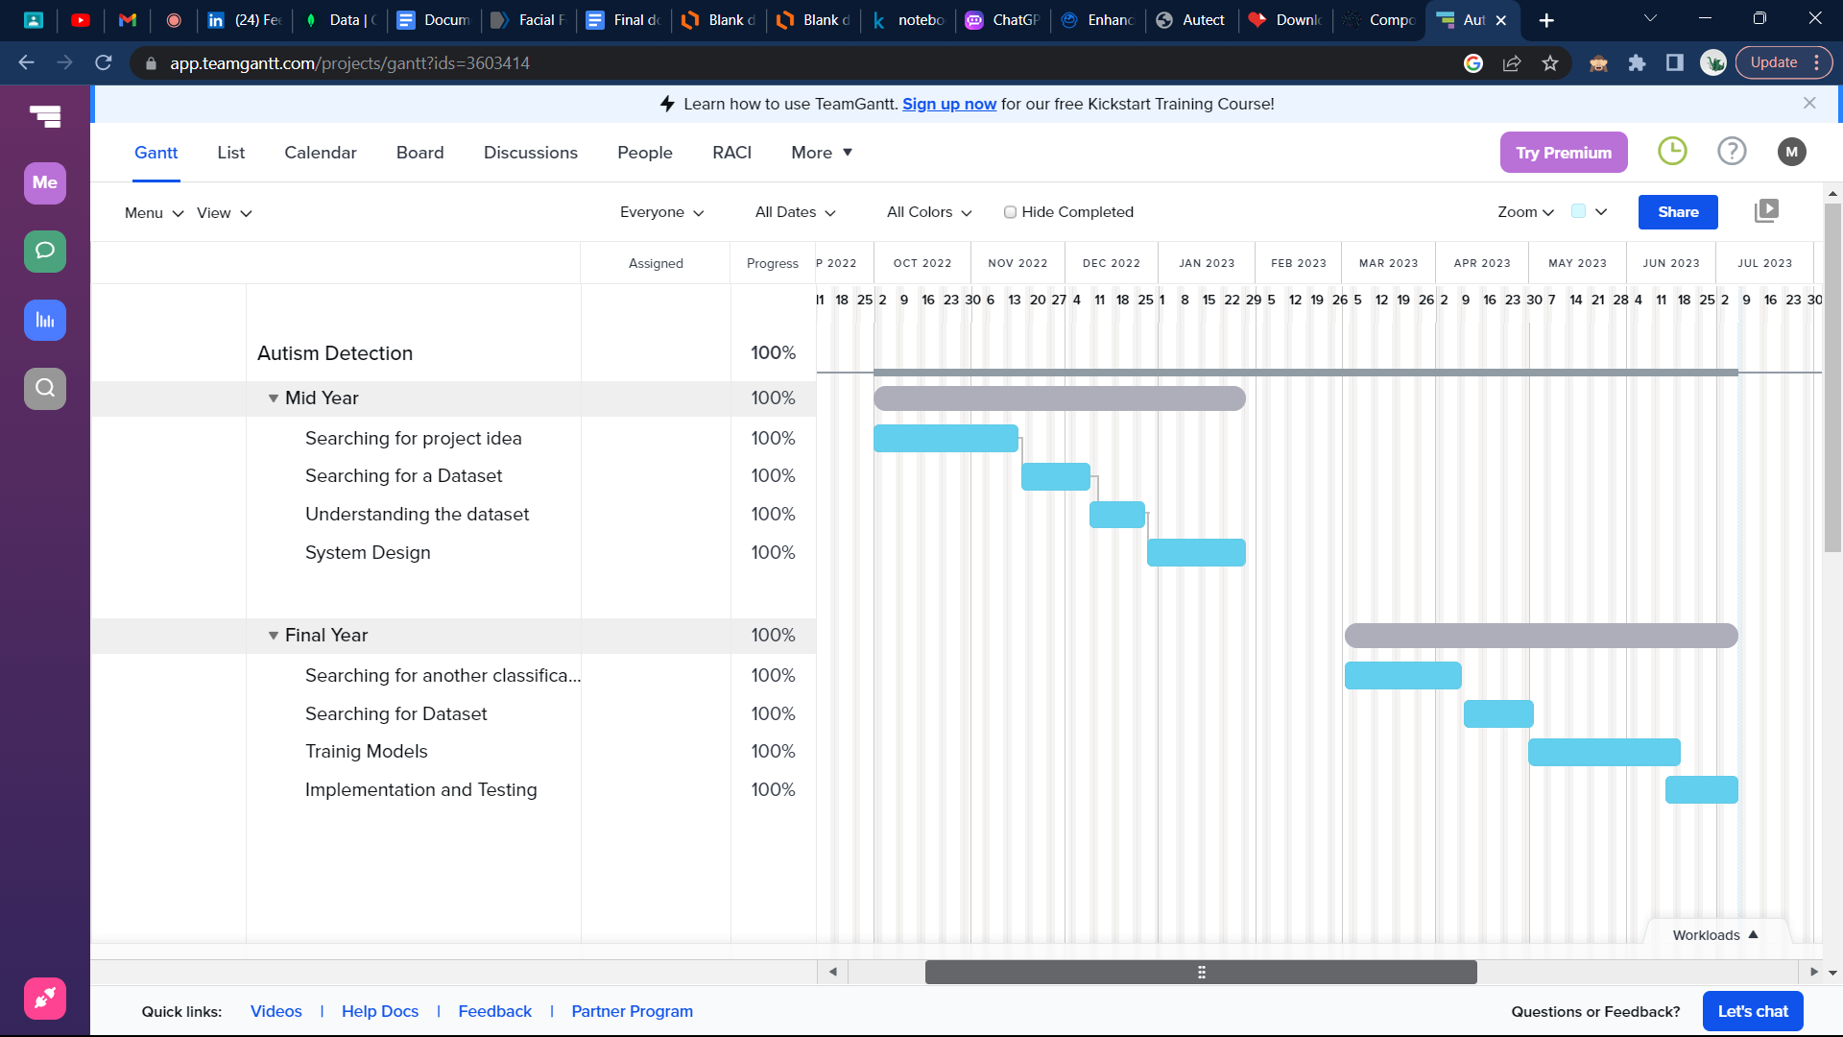**1.5. Gantt Chart of Project Time Plan**

Figure 1.5: Gantt Chart

**1.6. Project Development Methodology**

An approach that can be used is to use the waterfall methodology for the initial planning and design phase of the project. During this phase, the project team can define the requirements for the machine learning model, such as the input data, the output format, and the performance metrics. They can also define the requirements for the website, such as the design, functionality, and user experience. This phase can be completed before switching to an agile approach for the actual development and implementation of the project.

Once the planning and design phase is completed, the project can move to the development and implementation phase using the agile methodology. The development team can work in sprints, with each sprint focusing on a specific aspect of the website development or machine learning model development. The sprints can be planned in advance, with each sprint goal defined and agreed upon by all team members.

During each sprint, the development team can use CNN to detect autism and train the system to improve the accuracy of the detection. They can also work on developing the website using HTML, CSS, Flask, and JS. The agile methodology allows for flexibility, which means that the team can modify the sprint goals or adjust the development process to optimize the performance of the machine learning model or improve the functionality of the website as necessary.

An important aspect of using agile methodology is that the project team must prioritize communication and collaboration among team members. This involves having regular meetings and progress updates, sharing information, and addressing any issues or challenges promptly.

Furthermore, the project team can use agile methodologies like Scrum or Kanban to manage the development process. Scrum is a framework that emphasizes collaboration, frequent communication, and iterative development, while Kanban focuses on visualizing the workflow and limiting work in progress.

Overall, using both agile and waterfall methodologies in developing a project that uses machine learning CNN for detecting autism and building a website using HTML, CSS, Flask, and JS can be an effective approach. It allows for a structured approach to project management while also providing flexibility to adjust the development process and optimize the performance of the machine learning model or improve the functionality of the website. The key to success is effective communication and collaboration among team members throughout the project.

**1.7. The Tools Used in the Project**

. Programming languages: Python, HTML, CSS, JavaScript

. Machine learning libraries: TensorFlow, Keras, PyTorch, OpenCV

. Web development frameworks: Flask

. Code editors: PyCharm

. Version control system: Git, GitHub

. Database management systems: MongoDB

In addition to the software tools, hardware requirements for this project may include:

A GPU-accelerated server or workstation with a powerful graphics processing unit (GPU) to speed up the training process of the machine learning model.

**1.8. Report Organization**

Chapter 1 provides an introduction to the project, including the motivation behind it, the problem statement, the objectives, and the solutions. It also includes a Gantt chart outlining the project timeline and an overview of the development methodology and tools used.

Chapter 2 discusses related work in the field and highlights the differences between them and our project, emphasizing the benefits of our approach.

Chapter 3 presents the project specifications, including functional and non-functional requirements and a use case diagram.

Chapter 4 details the project design, including diagrams such as the system component diagram, system class diagram, sequence diagram, entity relationship diagram (ERD), and graphical user interface (GUI) design.

Chapter 5 covers the implementation and testing of the application. It outlines the materials and methods used, including the dataset and machine learning models and how they were implemented.

Chapter 6 presents the project results and discusses their significance.

Finally, Chapter 7 provides concluding remarks on the project and its outcomes.

**Chapter 2: Related Work**

. A study by Brain Sci. (2022) Identification of Autism in Children Using Static Facial Features and Deep Neural Networks

*Brain Sci et al. (2022) reported an accuracy of 88% in detecting autism using facial features*

.A study by [Comput Math Methods Med](https://www.ncbi.nlm.nih.gov/pmc/articles/PMC9001065/) et al. (2022)Facial Features Detection System To Identify Children With Autism Spectrum Disorder: Deep Learning Models

[*Comput Math Methods Med*](https://www.ncbi.nlm.nih.gov/pmc/articles/PMC9001065/) *et al. (2022) reported an accuracy of 94% in detecting autism using facial features*

. A study by Anzalone et al. (2014) used computer vision techniques to analyze facial features in children with autism and found that they had distinctive facial characteristics.

*Anzalone et al. (2014) reported an accuracy of 64% in detecting autism using facial features.*

. In a study by Shen et al. (2018), a deep learning approach was used to detect autism spectrum disorder (ASD) in children by analyzing facial features. The study achieved high accuracy in detecting ASD using facial images.

*Shen et al. (2018) achieved an accuracy of 85.9% in detecting autism using facial images.*

. Another study by Ozonoff et al. (2010) used a machine learning approach to analyze facial features in children with autism. The study found that certain facial features, such as a wider interocular distance, were more common in children with autism.

*Ozonoff et al. (2010) reported an accuracy of 70% in detecting autism based on facial features.*

. A study by Fernell et al. (2017) used a machine learning approach to analyze facial features in children with autism and found that they had distinct facial characteristics compared to typically developing children.

*Fernell et al. (2017) achieved an accuracy of 68.2% in detecting autism using facial features.*

. In a study by Van Santen et al. (2013), facial features were analyzed using both computer vision techniques and manual measurements. The study found that children with autism had distinct facial features, such as a wider mouth and shorter philtrum.

**The main differences between those studies and our project are:**

Use of a web application: Our project creates a web application for classifying autism, while the previous works do not necessarily involve a web application. This means that our project is more accessible and user-friendly for individuals who may want to use the tool remotely or from their own device.

Use of a pre-trained model: Our project uses a pre-trained model for classifying autism, while some of the previous works developed their own machine learning models from scratch. Using a pre-trained model can save time and resources and may result in a higher accuracy than developing a model from scratch.

Higher accuracy: Our project reports an accuracy of 90%, which is higher than the accuracies reported in some of the previous works. This may be due to various factors, such as the use of a pre-trained model, the size and quality of the dataset used, or the features used for analysis.

**Chapter 3: System Analysis**

**3.1. Project Specifications**

**3.1.1. Functional Requirements**

· Sign up function to create an account in the system

· Sign in function to log in the system to view and save recent results

· Sign out function to log out from the system

· Upload function to upload an image to the server

· Detect function to classify whether the image is autistic or not

· Display function to show the result of the classification

· Save function to save the recent results

**3.1.2. Non-functional Requirements**

· Response time: the system would show the results in less than 5 seconds

· Usability: has a user friendly interface

· Security: protects the data and information of the patient

· Reliability: the ability to operate with failure in a specific environment and duration time

**3.2. Use Case Diagram**

Figure 3.2:Use Case Diagram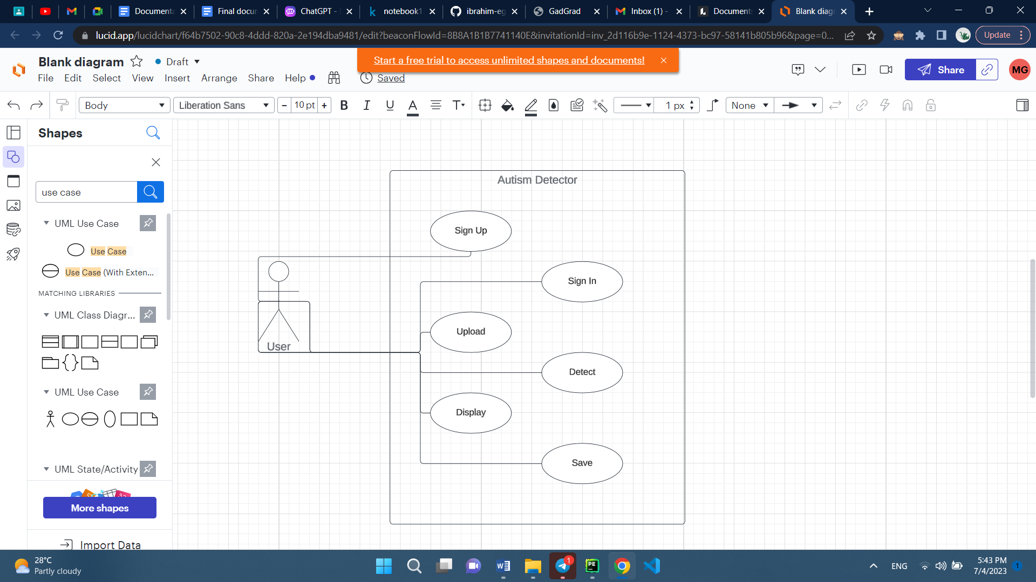

**Chapter 4: System Design**

**4.1. System Component Diagram**

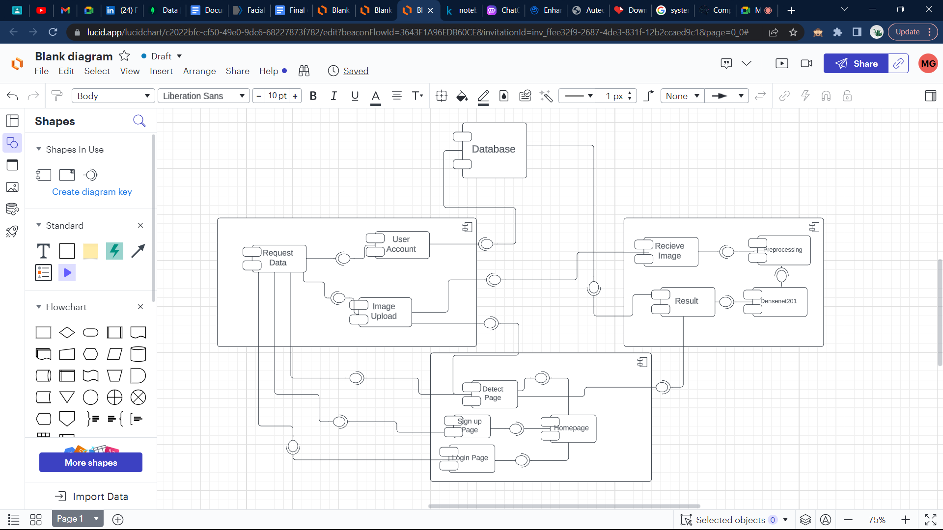

Figure 4.1: System Component Diagram

**4.2. System Class Diagram**

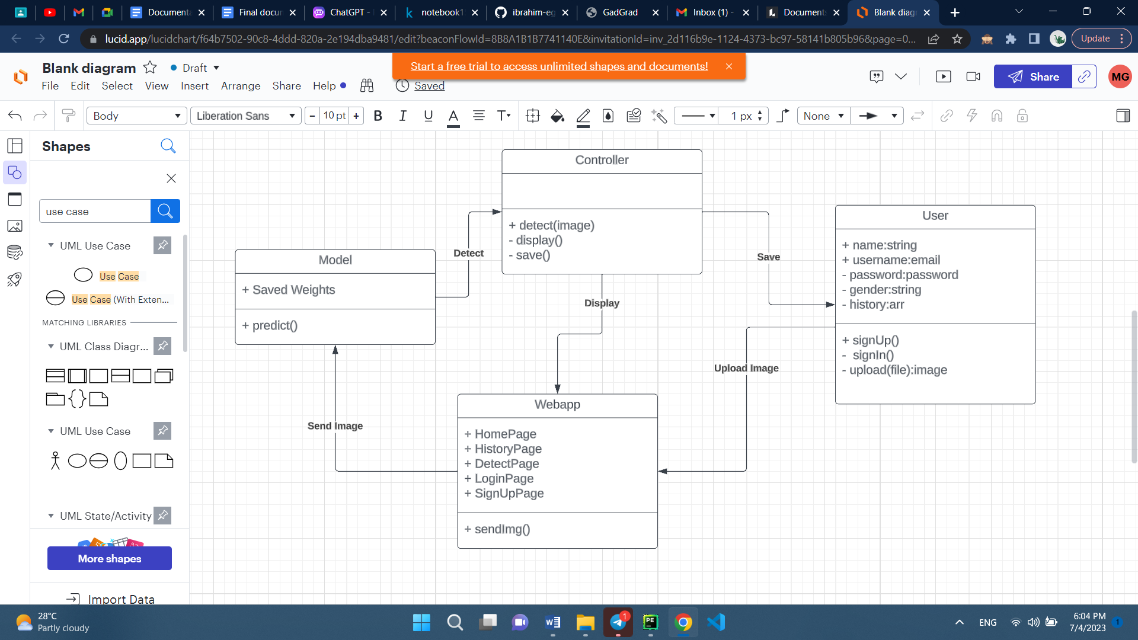

Figure 4.2: System Class Diagram

**4.3. Sequence Diagrams**

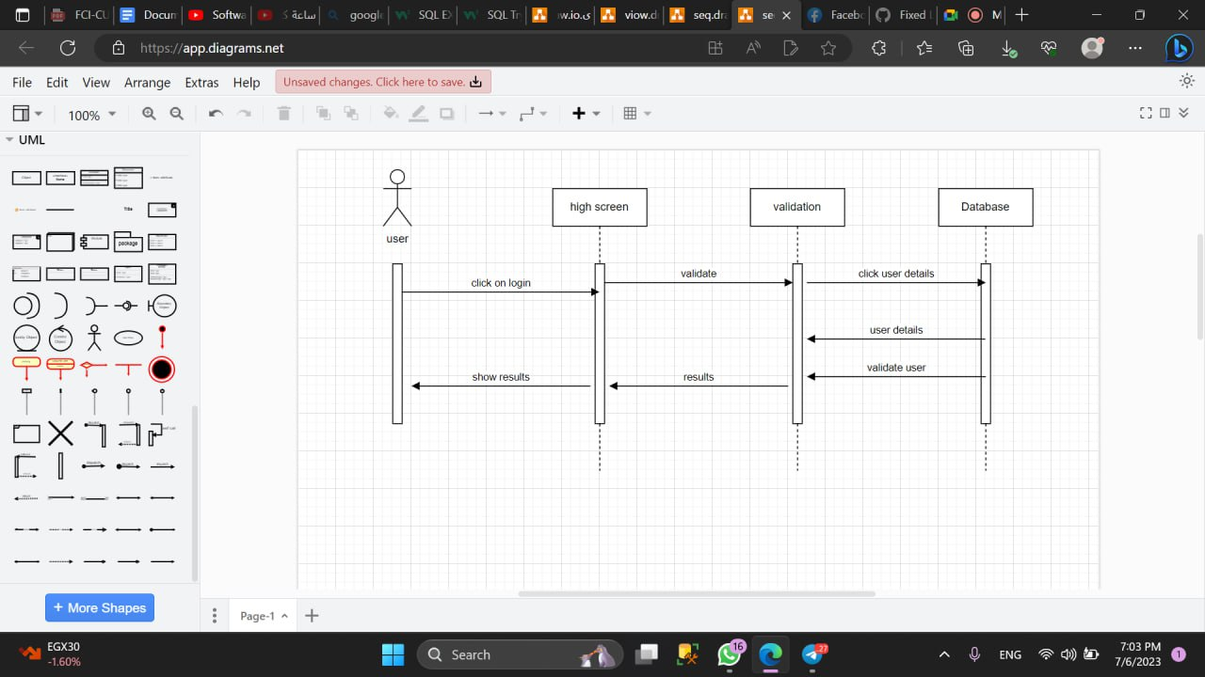**4.3.1. Login**

Figure 4.3.1: Login Sequence Diagram

**4.3.2. Upload image**

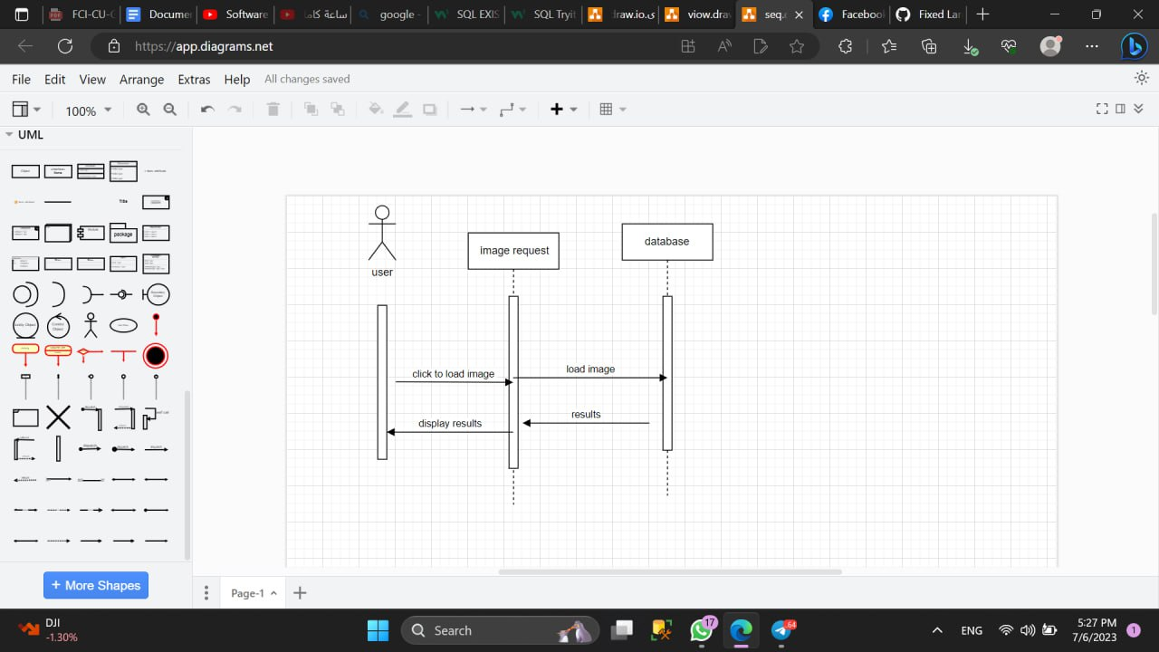

Figure 4.3.2: Upload Sequence Diagram

**4.3.3. View history**

Figure 4.3.3:View History Sequence Diagram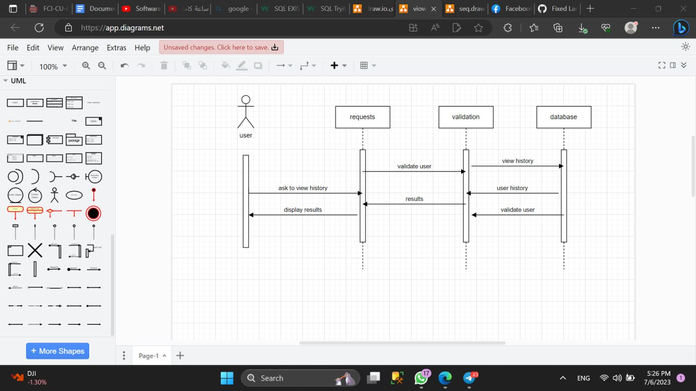

**4.4. Project ERD**

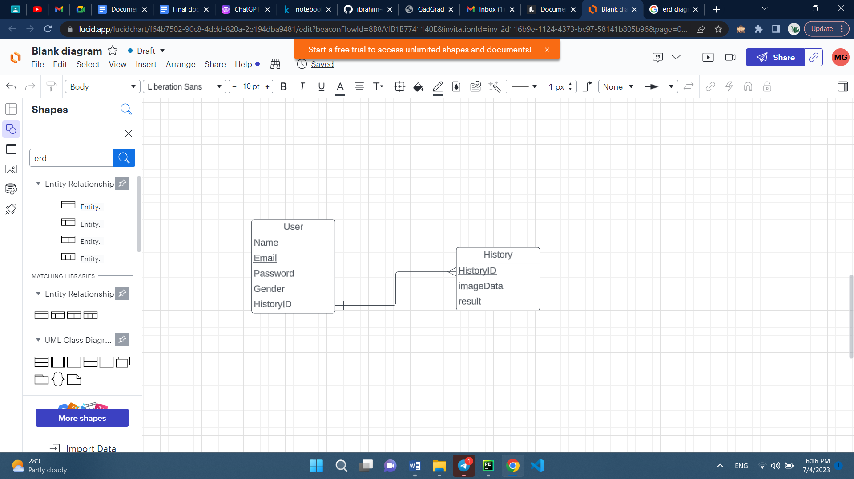

Figure 4.4: ERD Diagram

**4.5. System GUI Design**

Figure 4.5.1:Home Page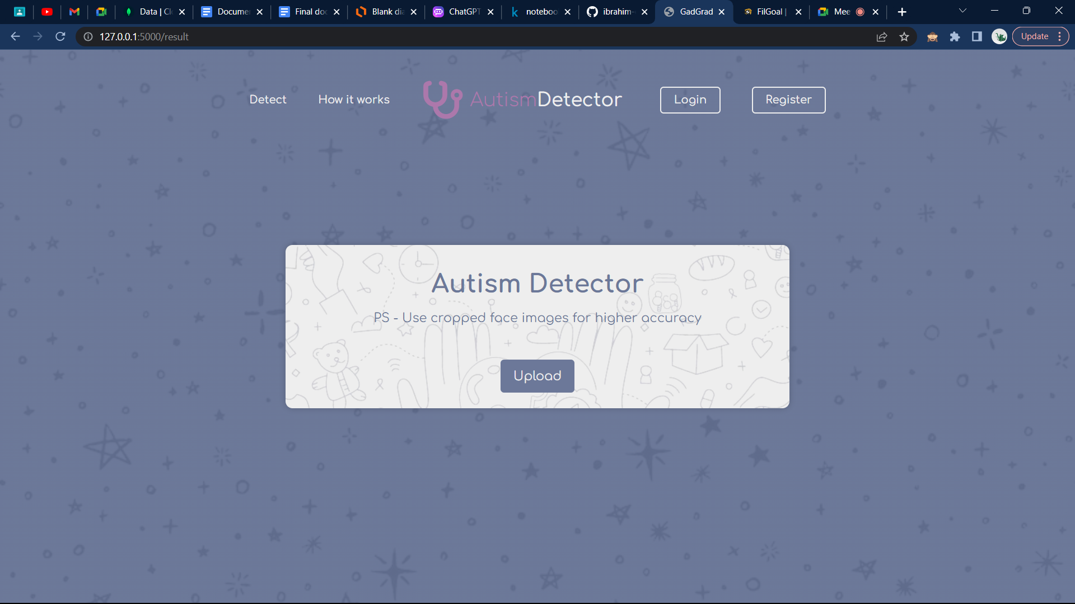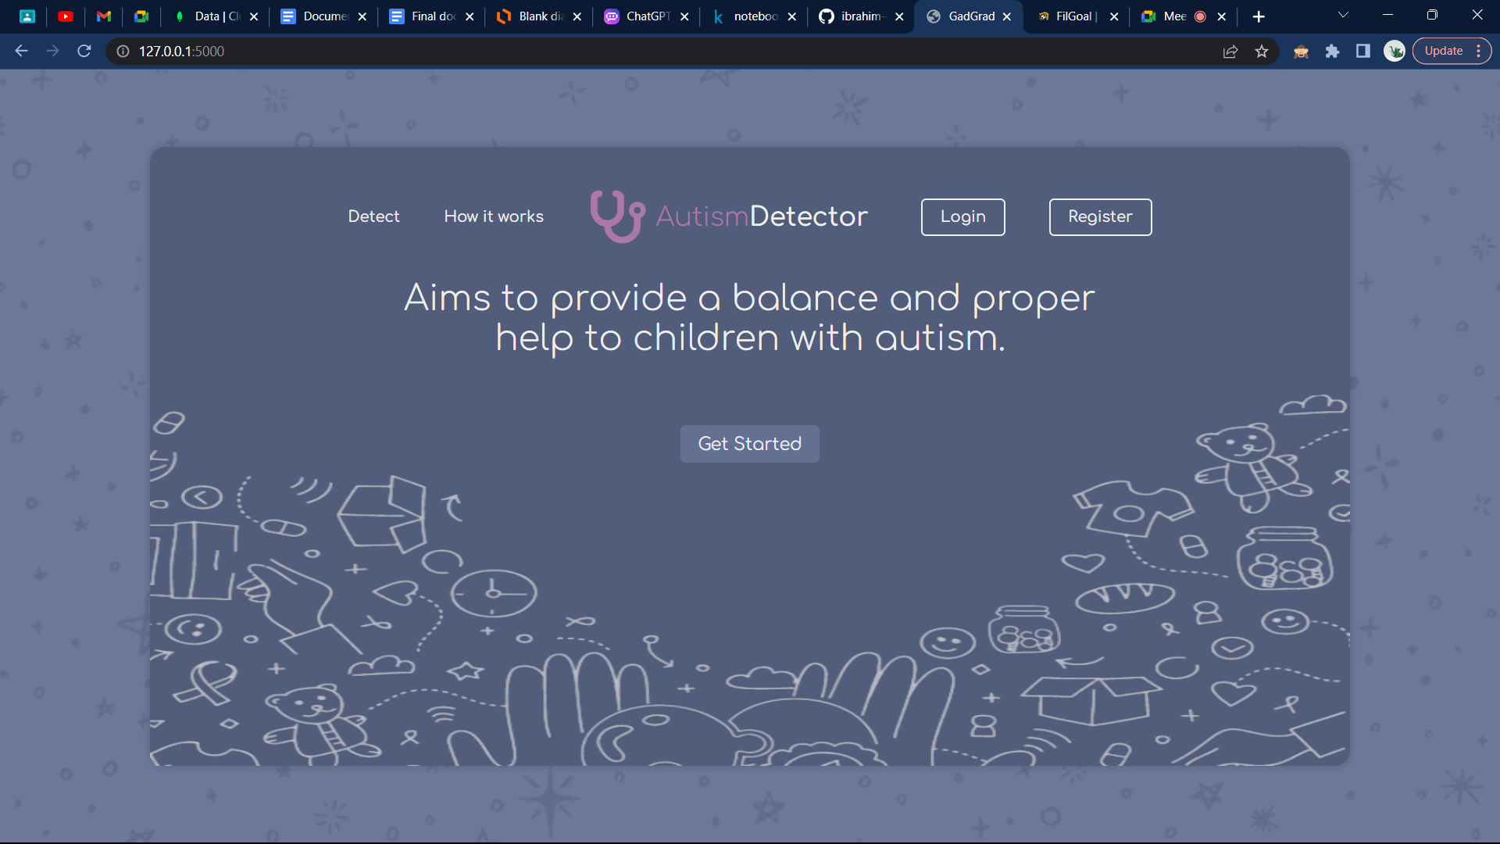

Figure 4.5.2: Detection Page

Figure 4.5.3: Instruction Page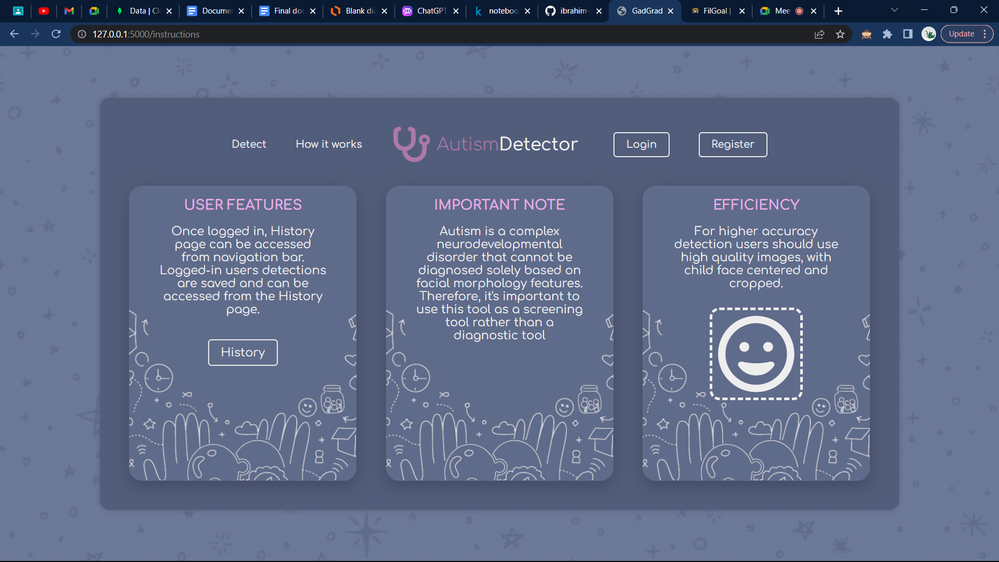

Figure 4.5.4: Login Page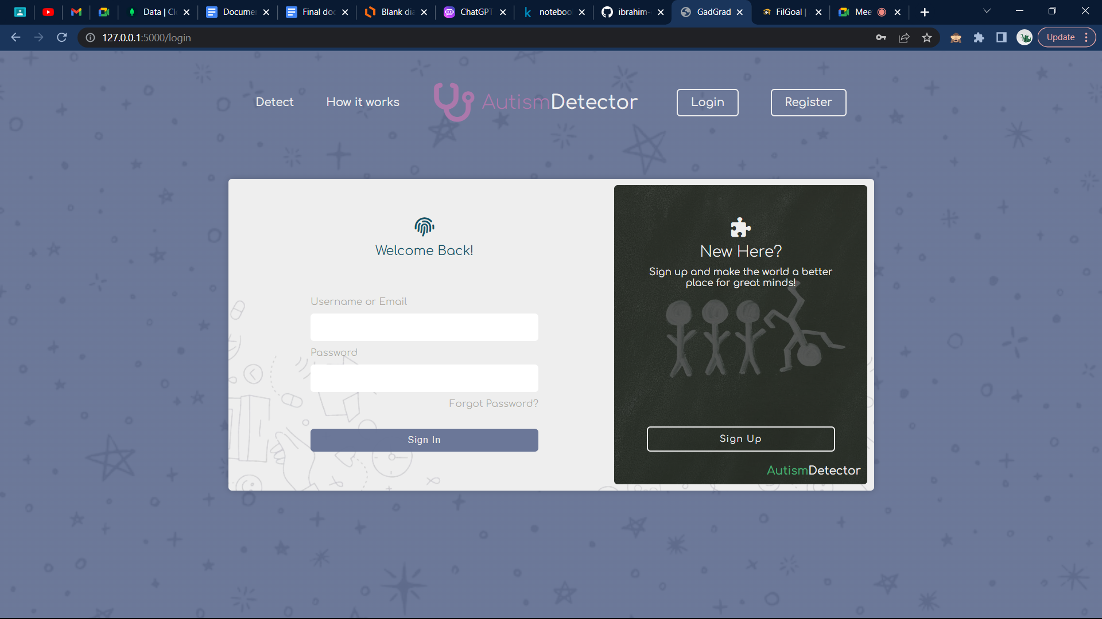

Figure 4.5.5: Sign up Page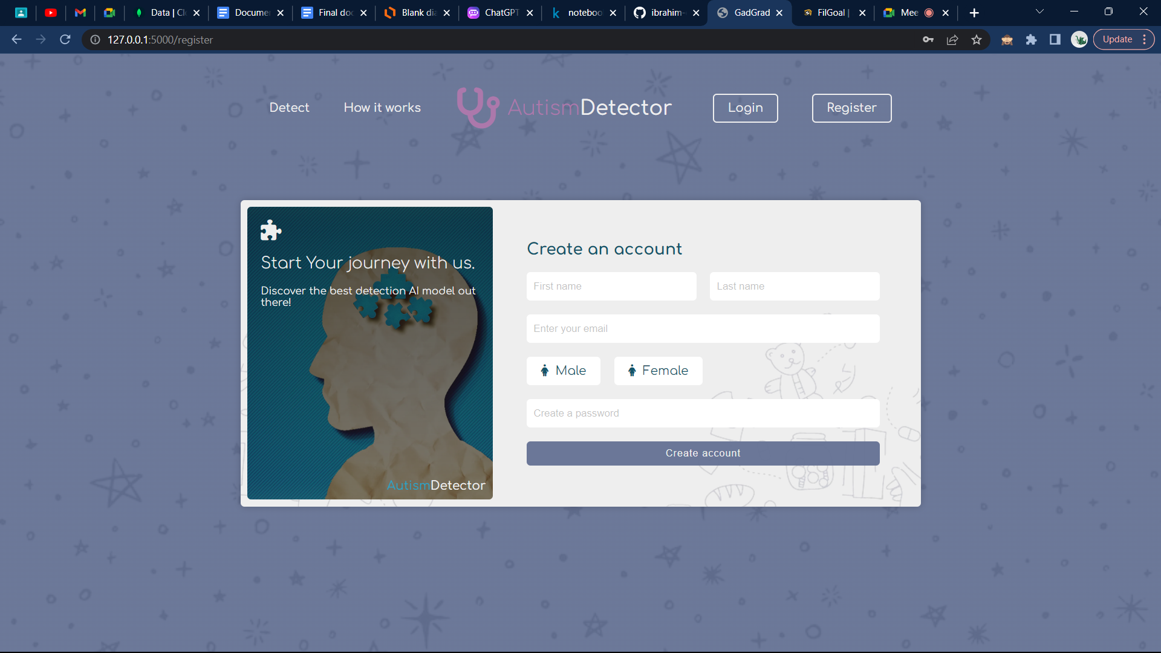

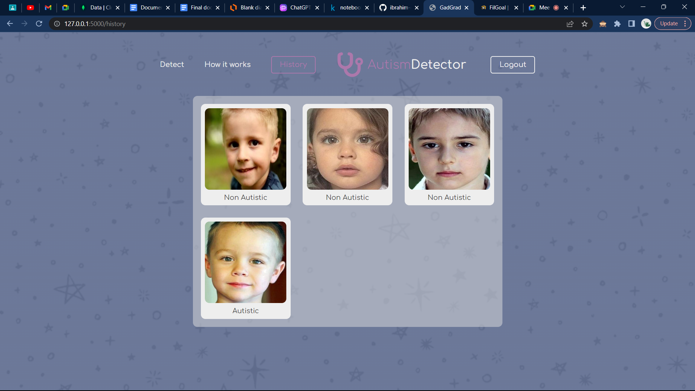

Figure 4.5.6: History Page

**Chapter 5: Material and Methods**

**5.1. Dataset**

The dataset contains facial images of children and is composed of two classes: autistic and non-autistic. The autistic class contains images of children who have been diagnosed with autism, while the non-autistic class contains images of children who have not been diagnosed with autism. The images in the dataset are in RGB format, meaning that they consist of red, green, and blue color channels that create a full-color image. The images are of various shapes and sizes, and all are in JPG format, which is a commonly used image format that allows for high-quality compression of digital images. The dataset provides a valuable resource for training machine learning models to detect autism from facial images, which could potentially aid in the early diagnosis of autism and improve outcomes for individuals with this condition.

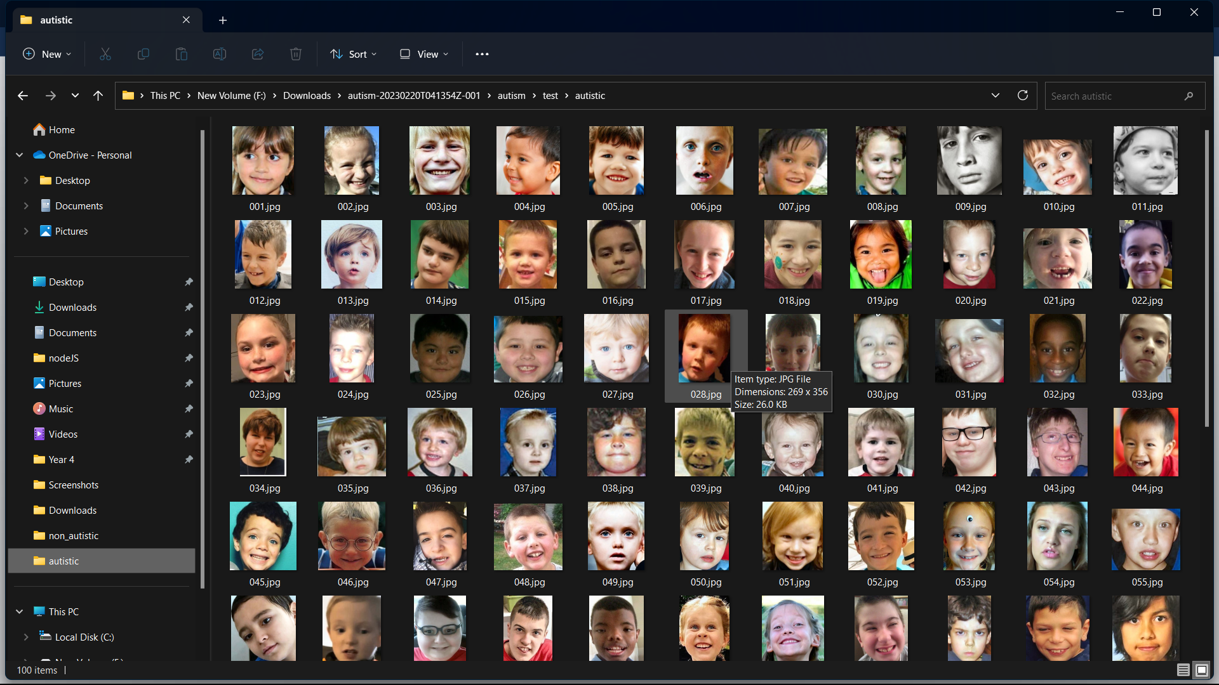

Figure 5.1.1: Autistic Class

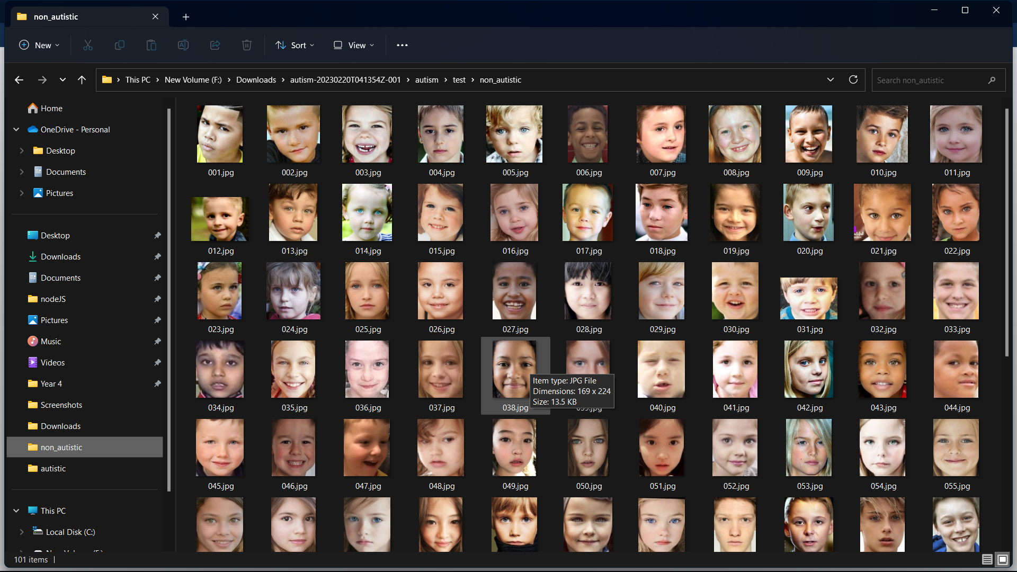

Figure 5.1.2: Non Autistic Class

**5.2. Pipeline**

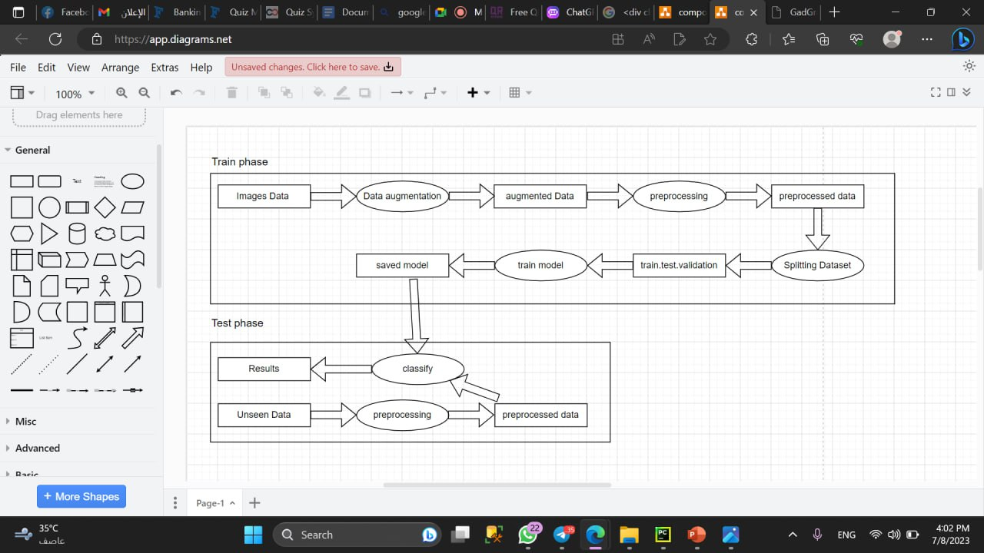

Figure 5.2: Pipeline Diagram

**5.2.1. Data Collection**

Despite extensive search efforts, it was discovered that no existing database contained facial images of autistic children. As a result, a dataset had to be created by sourcing images from the internet, primarily from websites that focused on autism. The process involved downloading images and manually cropping the child's face, which was a time-consuming and laborious endeavor, especially considering the need for thousands of images. The dataset that resulted from this process was of varying quality, with several limitations such as images being partially in profile, small in size, and lacking detailed facial morphology information. Variations in lighting conditions, rotation angles, and other factors were also present, which further decreased the quality of the dataset.

Despite these limitations, the dataset serves as a reasonable starting point for training machine learning models to detect autism from facial images. Although efforts were made to create a higher-quality dataset by contacting several autism-related organizations, they were unsuccessful. It should also be noted that there is a possibility of some percentage of autistic images being present in the non-autistic folders, as it was not possible to selectively search for non-autistic children's facial images on the internet. Nonetheless, this dataset represents a valuable resource for advancing research on autism detection from facial images.

**5.2.2. Data Augmentation and Preprocessing**

Preprocessing step:

The preprocessing step involves applying the "preprocess_input" function from the Keras "inception_resnet_v2" model to normalize the pixel values of the images. This step is important to ensure that the pixel values fall within a certain range and have a consistent distribution, which can improve the performance of machine learning models trained on the dataset. The preprocessing step is applied to each image in the dataset before any data augmentation techniques are applied.

Data augmentation step:

The data augmentation step involves using the "ImageDataGenerator" function from the TensorFlow library to apply various transformations to the images in the dataset. This step is important to increase the diversity of the dataset and improve the performance of machine learning models trained on the dataset. The specific augmentations applied to the images include shifting the width and height by up to 20%, shearing by up to 20%, zooming by up to 20%, and flipping horizontally. The "fill_mode" parameter determines how the function fills in any empty pixels that may result from these transformations.

**5.2.3. Feature Extraction**

Feature extraction is an important step in machine learning that involves identifying and selecting the most relevant features (or attributes) from a dataset for use in training a machine learning model. In the case of this dataset of facial images of autistic and non-autistic children, feature extraction is a critical step that can help to improve the accuracy of machine learning models trained on the dataset.

DenseNet201 is a popular pre-trained CNN model that has been shown to achieve high accuracy on image classification tasks. The model consists of multiple dense blocks, which are composed of several convolutional layers and pooling layers. These blocks allow for the efficient extraction of high-level features from images, which can be used for classification tasks.

In the context of this dataset, using DenseNet201 for feature extraction involves passing each image through the model and extracting the output of the last convolutional layer. This output represents the most important features of the image, and can be used as input to a machine learning model, such as a neural network, to train the model to classify the images as autistic or non-autistic.

Overall, using DenseNet201 as a pre-trained model for feature extraction is a powerful technique for improving the accuracy of machine learning models trained on this dataset. By leveraging the pre-trained model's ability to efficiently extract high-level features from images, we can improve the performance of our machine learning models and potentially make significant advancements in the field of autism detection from facial images.

**5.2.4. Models Training and Testing**

After feature extraction, the next step in the machine learning pipeline is to train and test a model on the extracted features. The goal of this step is to create a machine learning model that can accurately classify facial images as autistic or non-autistic.

In this dataset, a common approach to model training and testing is to use a supervised learning technique such as a support vector machine (SVM) or a neural network. The extracted features from each image are used as input to the model, along with the corresponding labels (autistic or non-autistic).

The dataset is typically split into training and testing sets, with a portion of the data reserved for testing the accuracy of the trained model. The training set is used to train the model on the extracted features, while the testing set is used to evaluate the accuracy of the trained model. It is important to ensure that the testing set is representative of the overall dataset to obtain an accurate estimate of the model's performance.

The model is typically trained using the DenseNet201 pre-trained model with the weights preloaded from the ImageNet dataset. The last 28 layers of the model are excluded, and the output from the remaining layers is then flattened and connected to a fully connected layer with 50 neurons and a ReLU activation function. A final output layer consisting of two neurons with a softmax activation function is used for binary classification of the images as either autistic or non-autistic.

The model is compiled using the Adam optimizer with a learning rate of 0.01 and epsilon of 0.1, and the categorical cross-entropy loss function is used for training. The accuracy metric is used to evaluate the performance of the model during training and testing.

Once the model is trained, it is evaluated on the testing set to obtain an estimate of its accuracy. This step typically involves computing metrics such as precision, recall, and F1 score to evaluate the model's performance.

Overall, the process of model training and testing is critical in creating a machine learning model that can accurately classify facial images as autistic or non-autistic. By carefully selecting a model and optimization algorithm, tuning hyperparameters, and evaluating the model's performance on a representative testing set, we can create a powerful tool for autism detection from facial images.

**5.3. Implementation of the Application**

**5.3.1. Model Implementation**

1-Splitting dataset into train, test and valid after preprocessing and augmentation

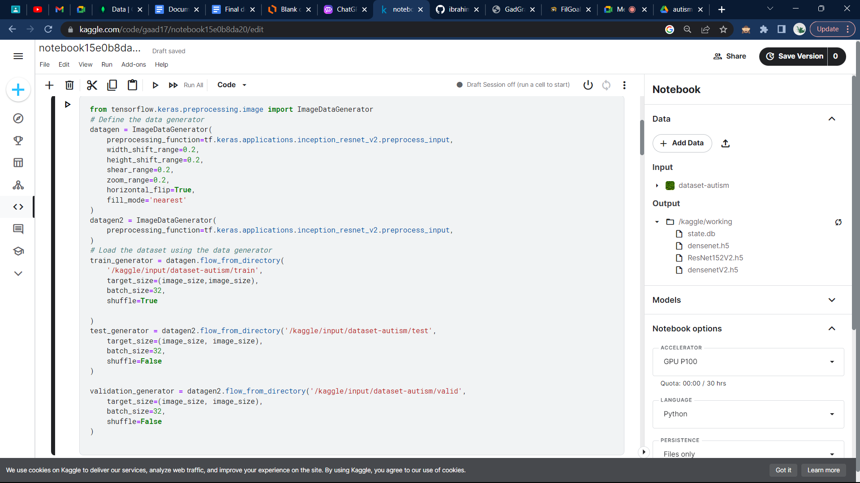

Figure 5.3.1.1: Splitting Data, Augmentation, Preprocessing

2- Densenet201 pretrained model with 50 neuron dense layer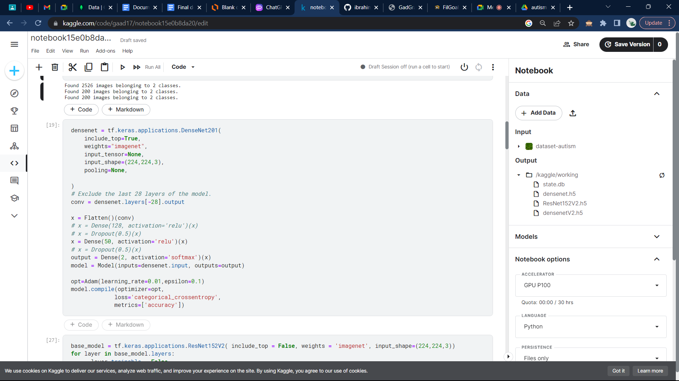

Figure 5.3.1.2: Densenet model implementation

3- Train Model with 30 epoch

Figure 5.3.1.3:Train Model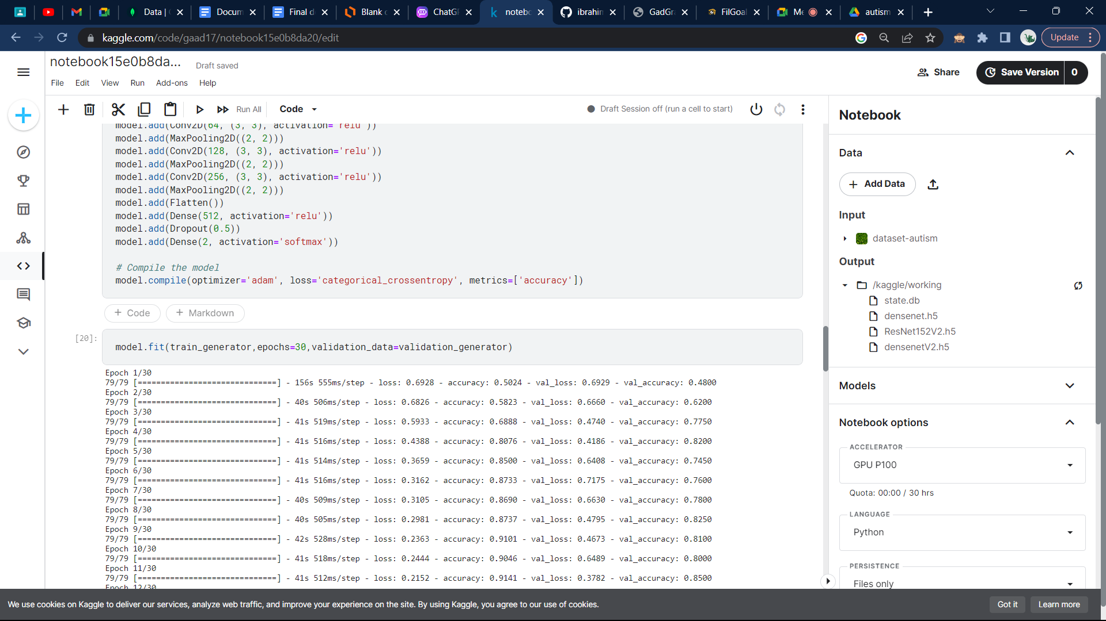

4- Accuracy Report

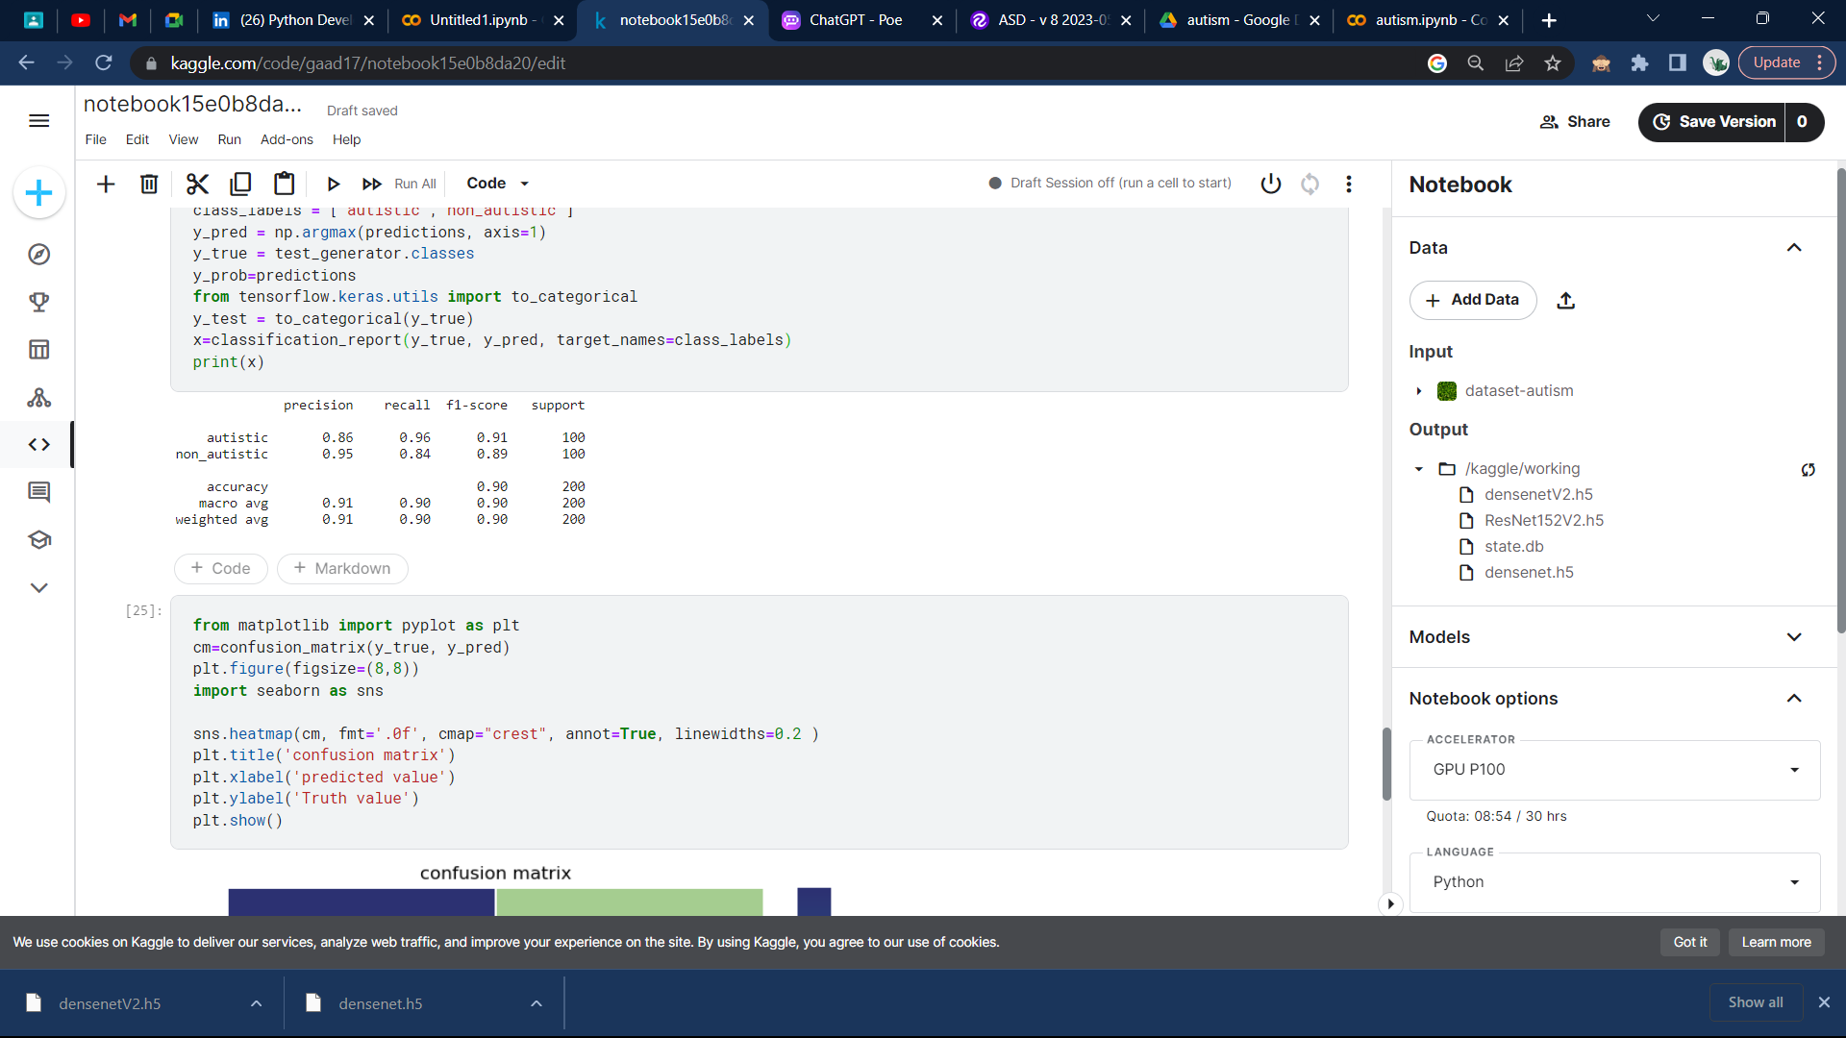

Figure 5.3.1.4: Accuracy Report using F1-Score recall precision

5- Confusion Matrix

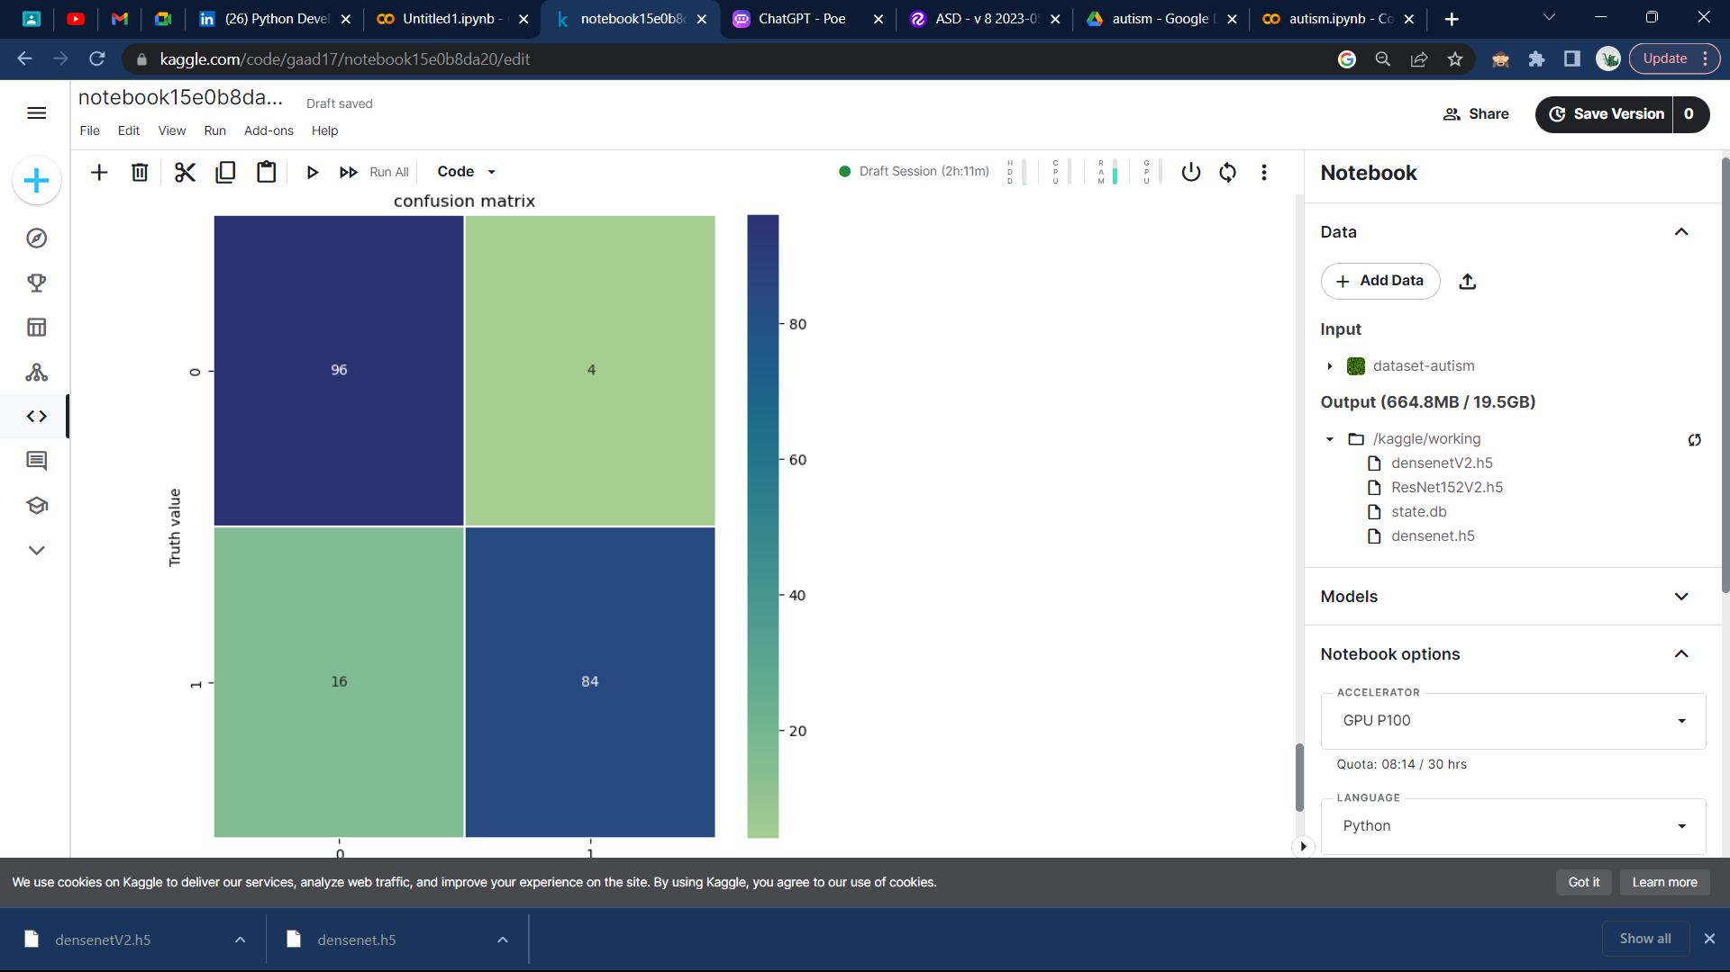

Figure 5.3.1.5: Confusion Matrix

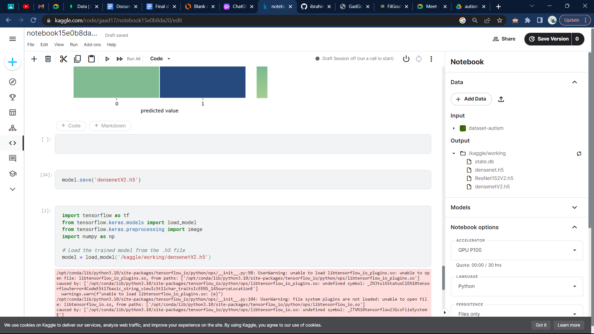6- Save Model

Figure 5.3.1.6: Save Model

**5.3.2. Front and Back implementation**

1- Some examples for the back and front of the app:

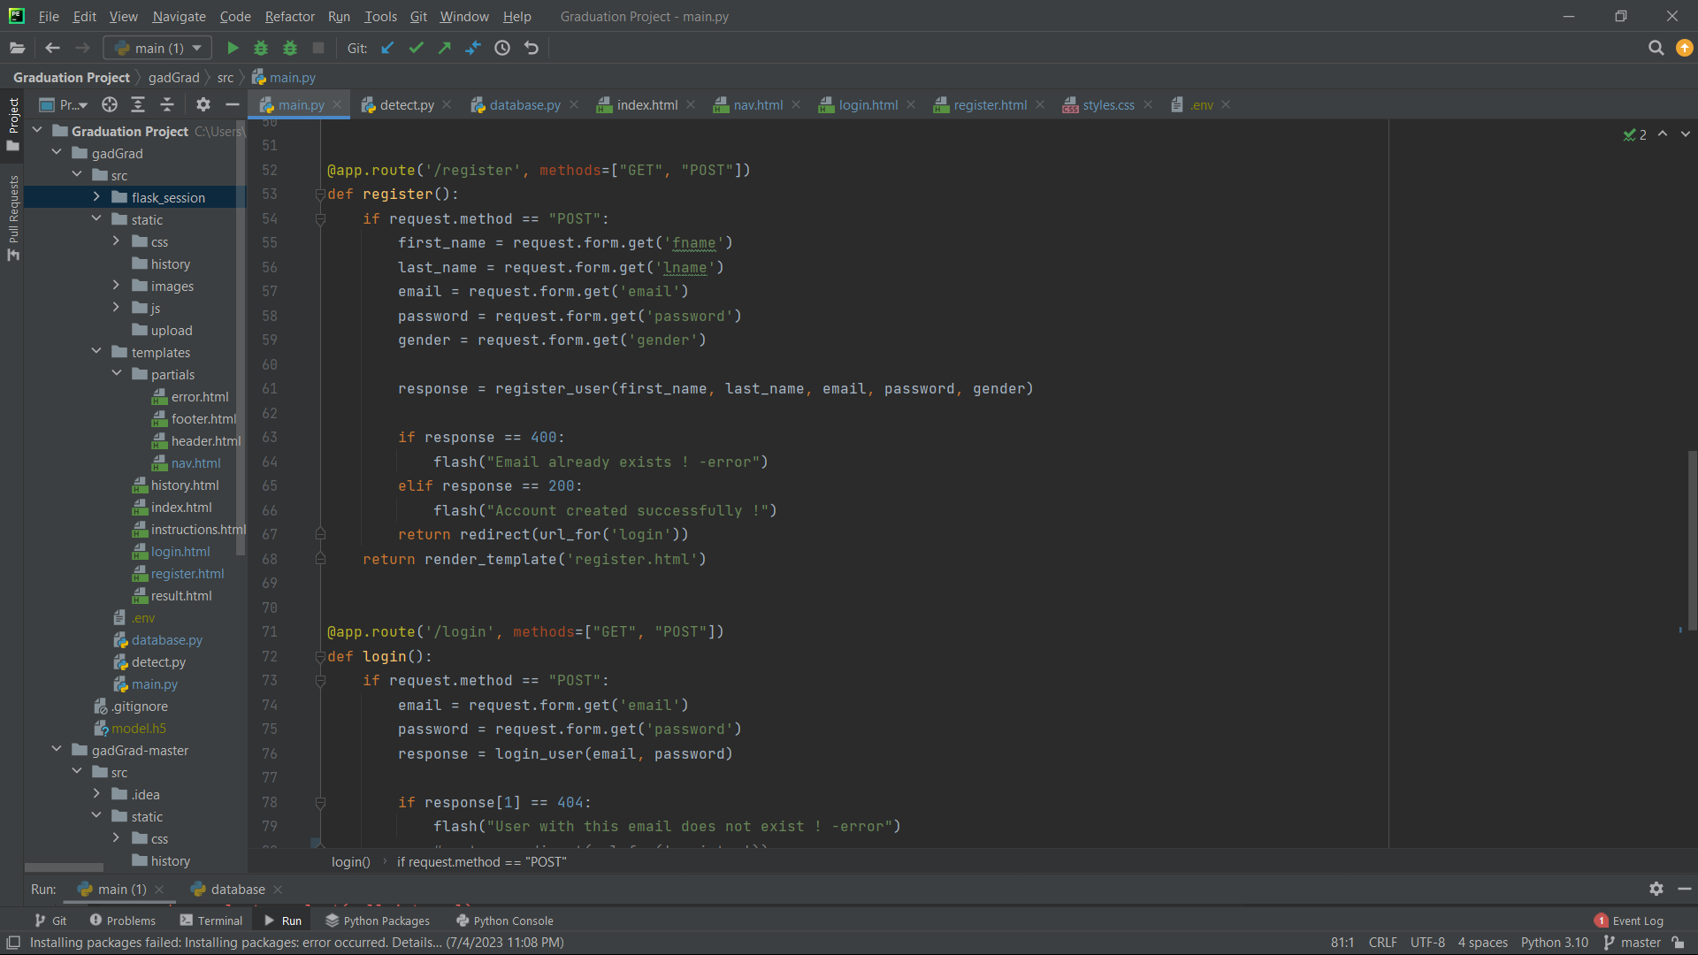

Figure 5.3.2.1: Main controller

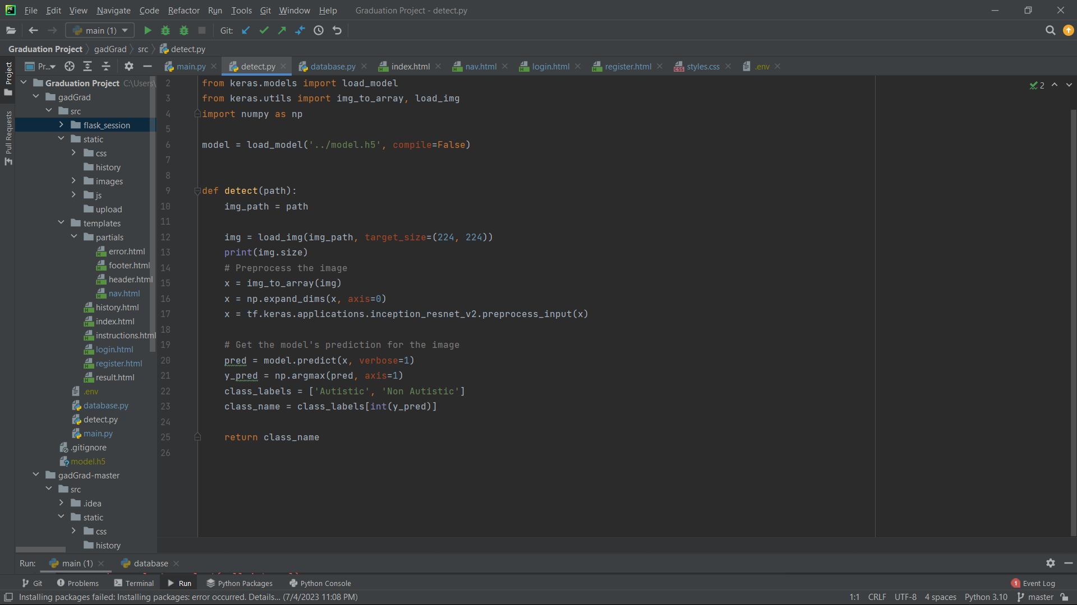

Figure 5.3.2.2: detect autism function

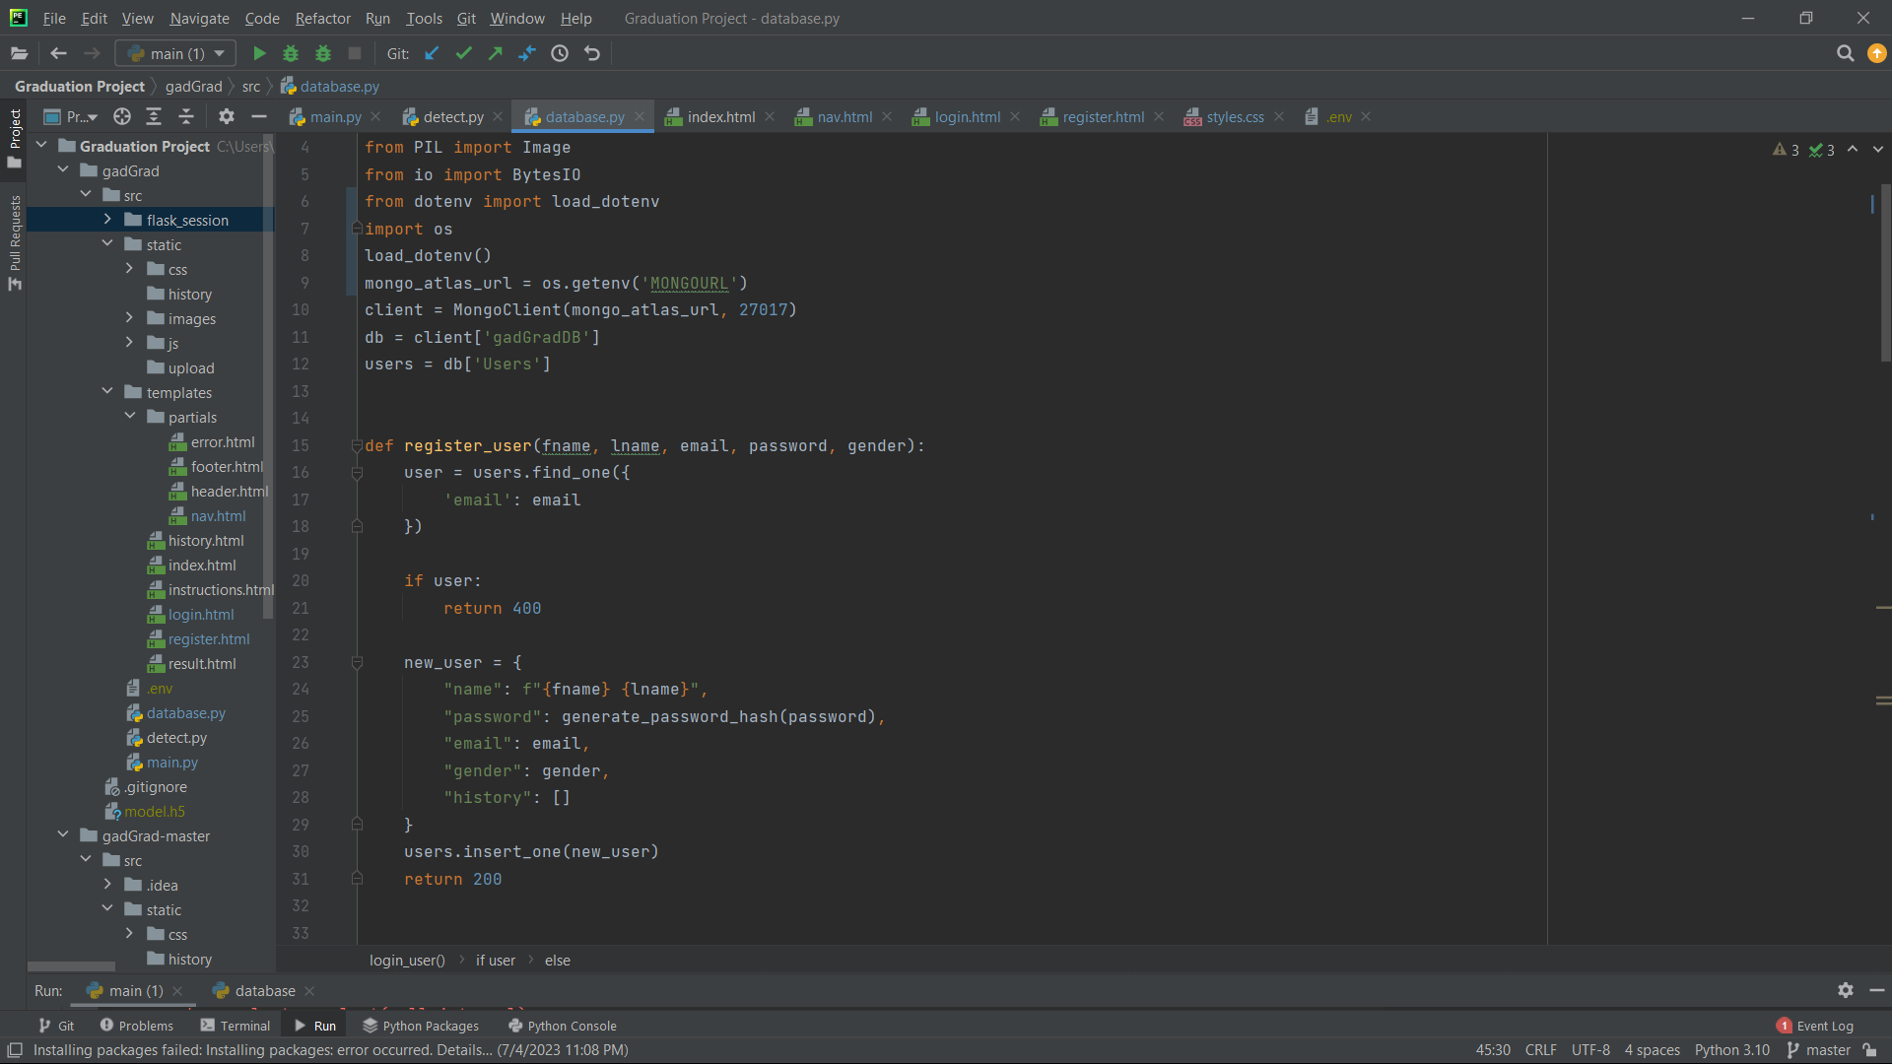

Figure 5.3.2.3: creating database

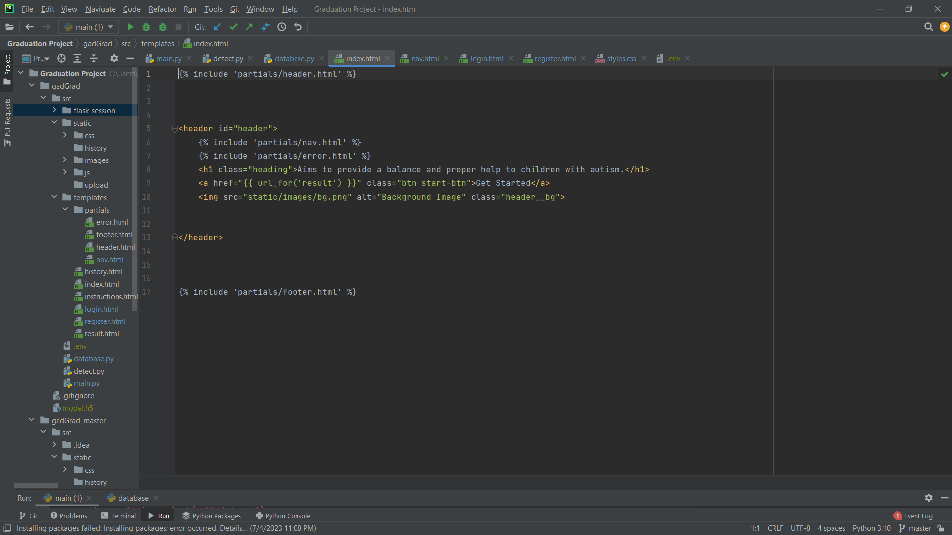

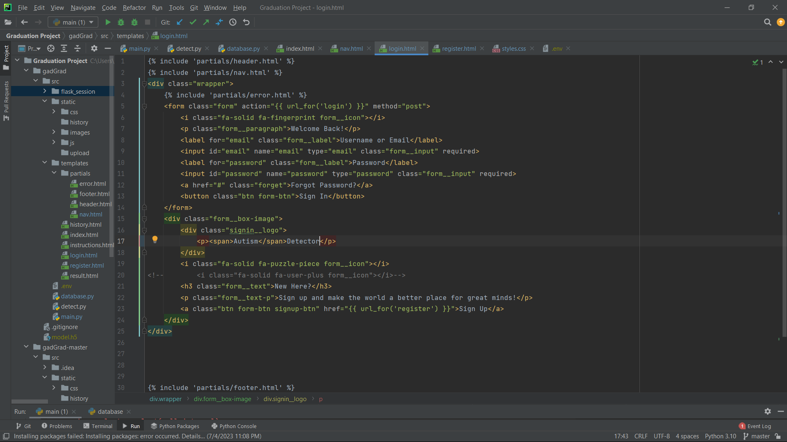Figure 5.3.2.4: homepage design

Figure 5.3.2.5: login page design

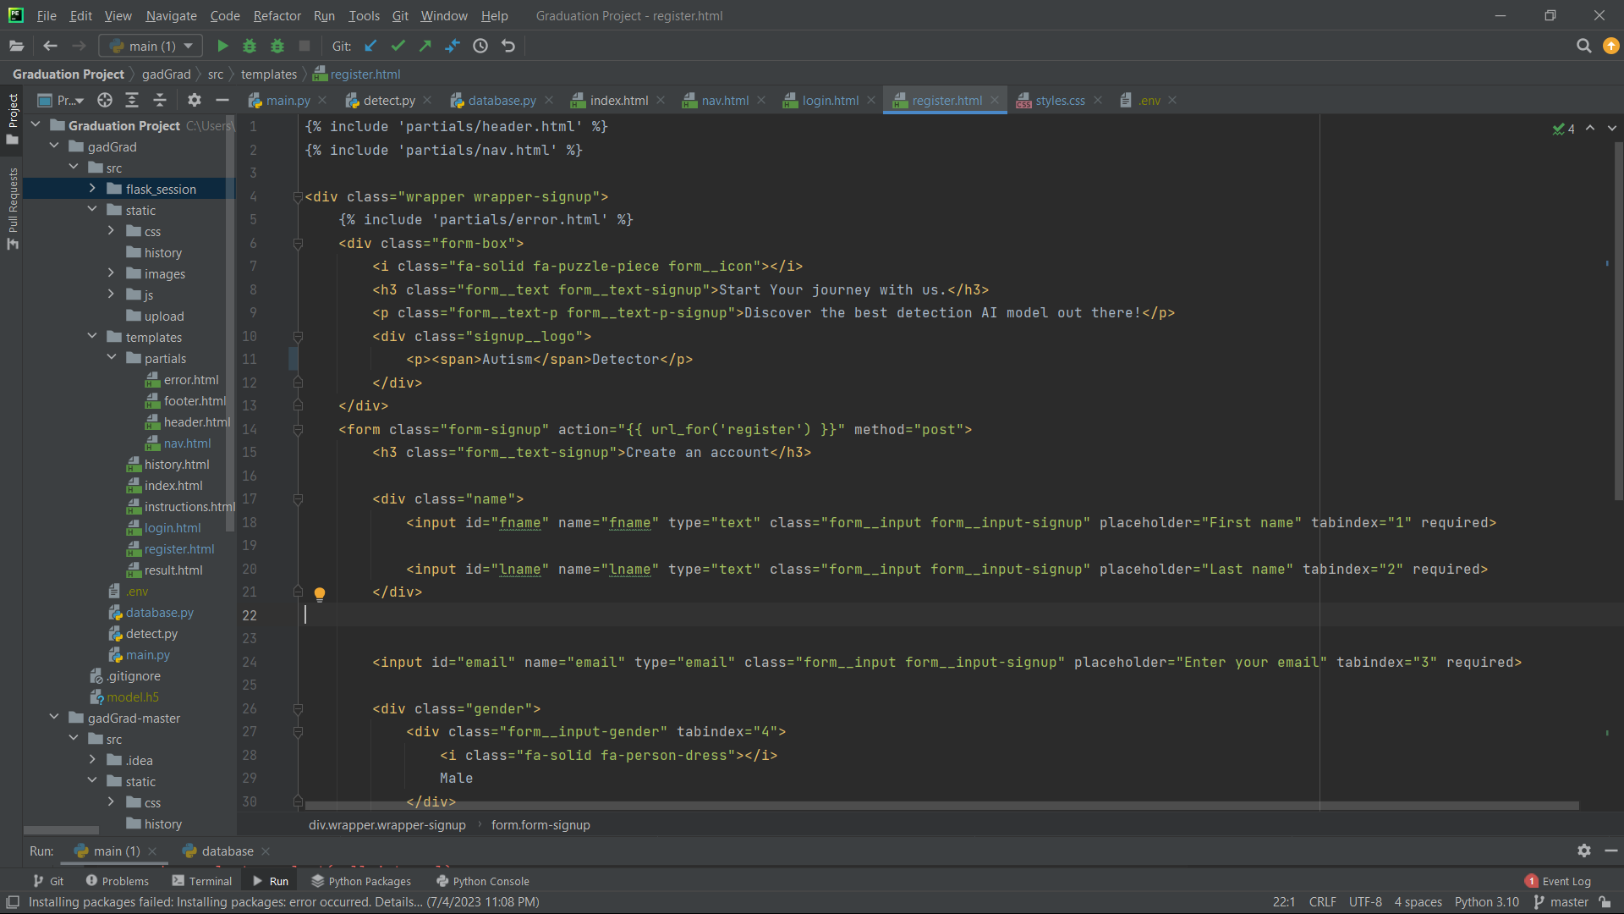

Figure 5.3.2.6: register page design

**5.4. Testing**

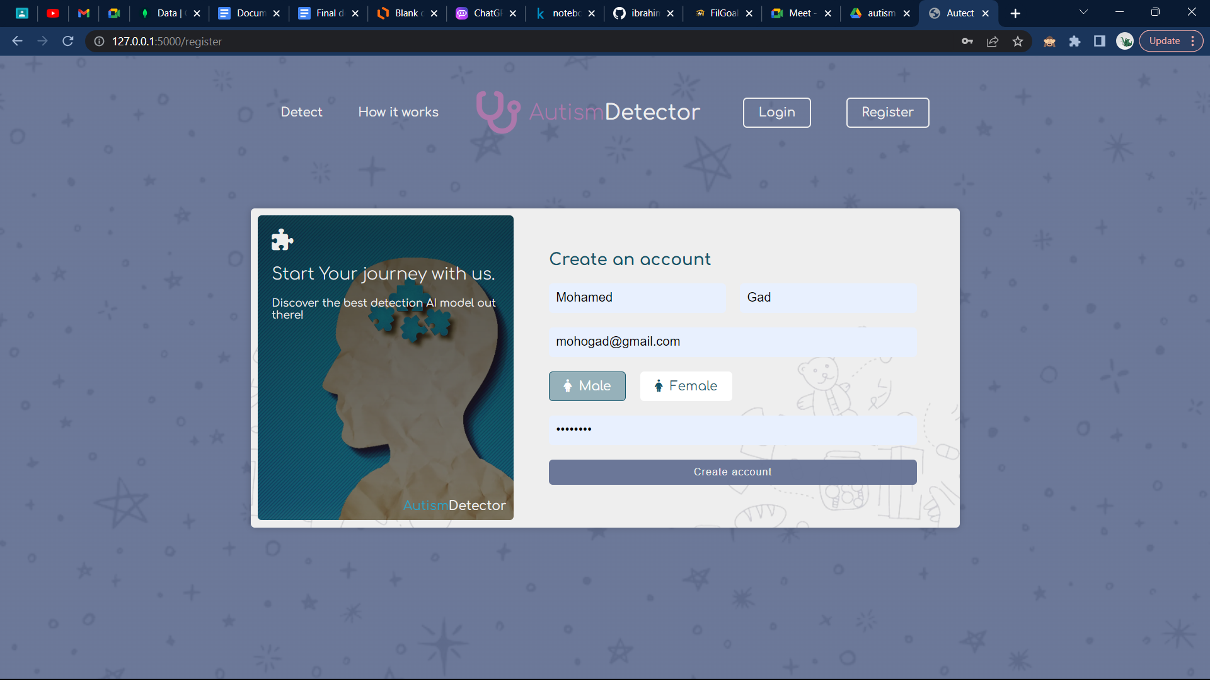**5.4.1 User creating account**

Figure 5.4.1: Creating Account

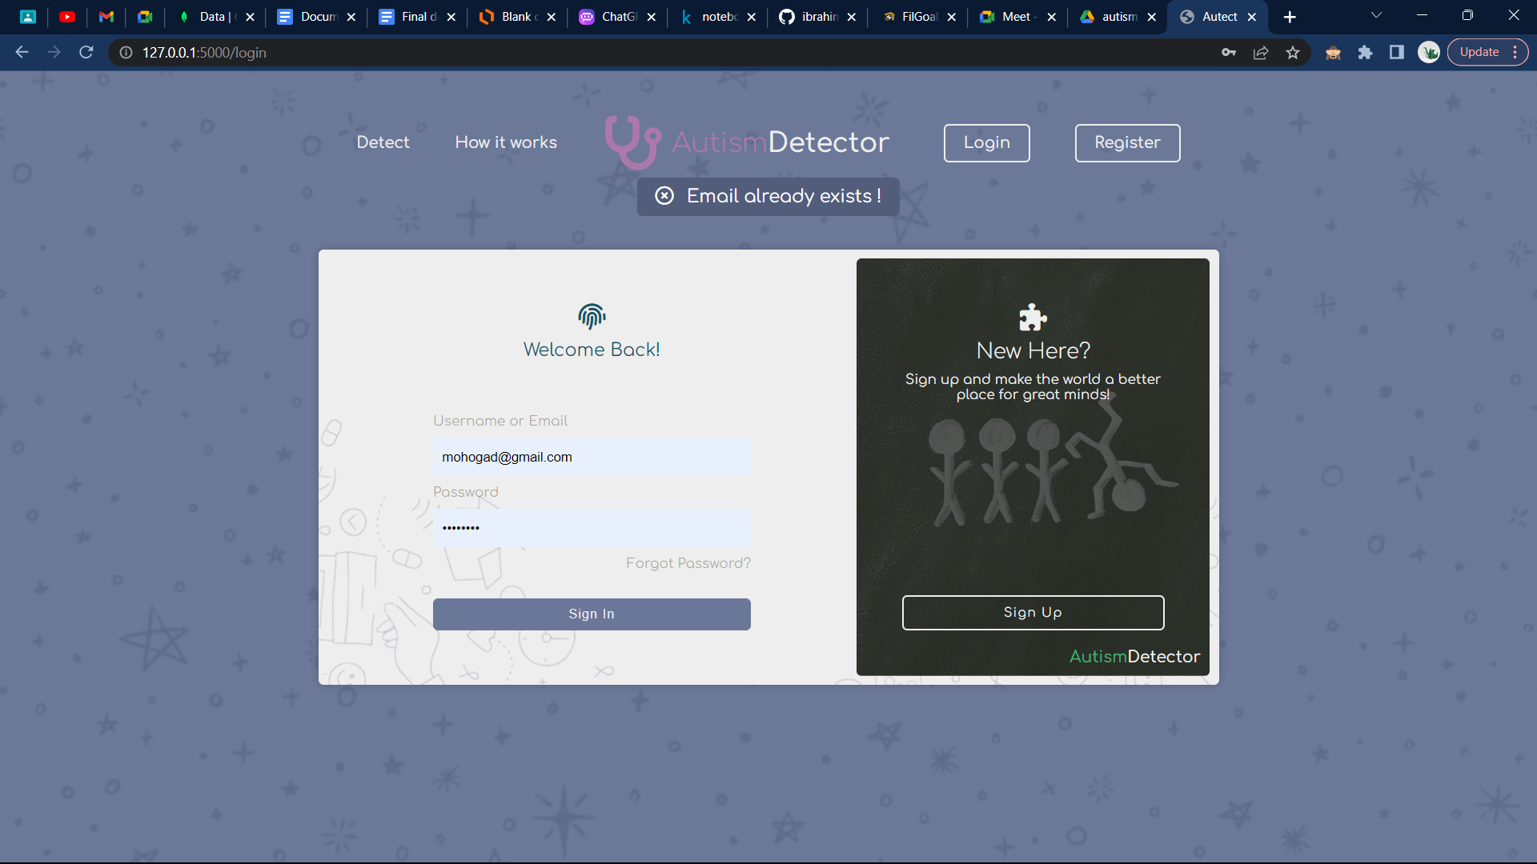**5.4.2 User creating account error**

Figure 5.4.2: Email error

**5.4.3. User creating account success**

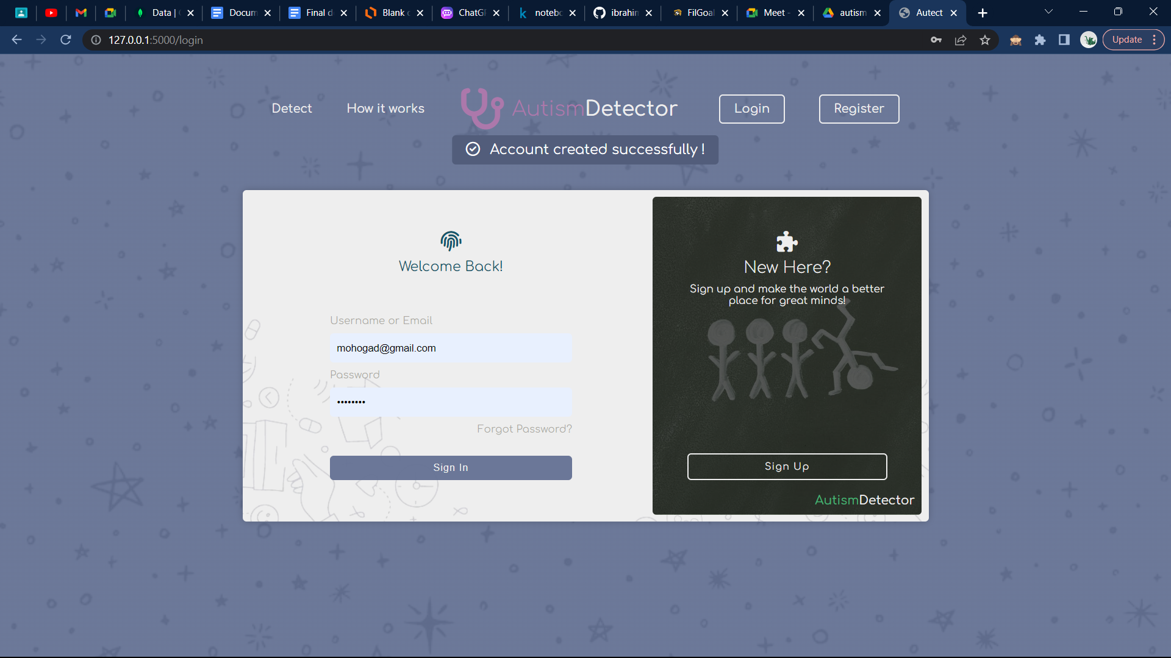

Figure 5.4.3: Create Success

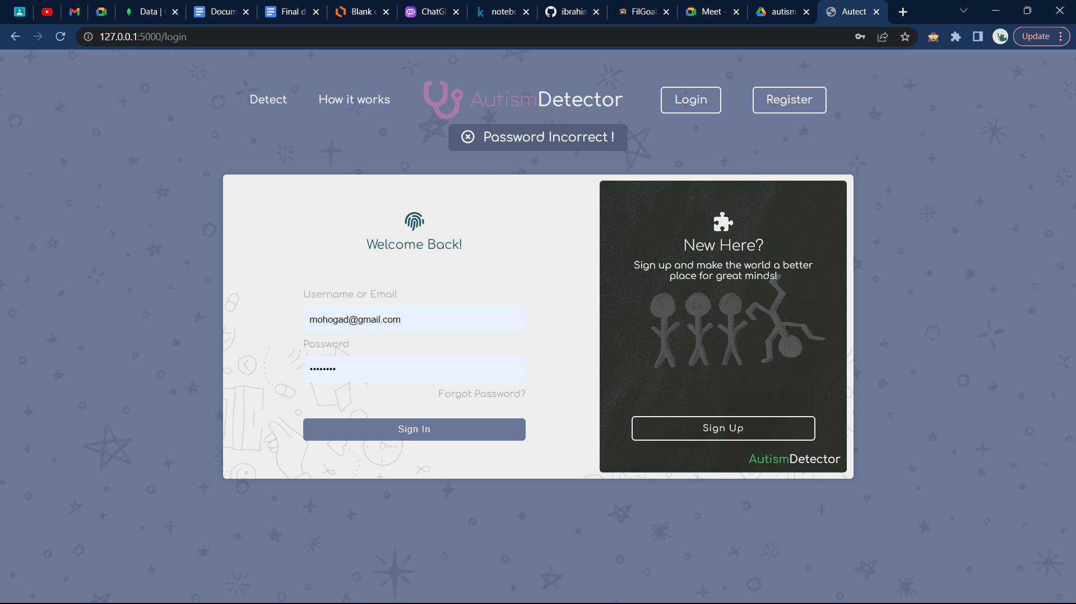**5.4.4. User login error (Password)**

Figure 5.4.4: Password error

**5.4.5. User login error (Email)**

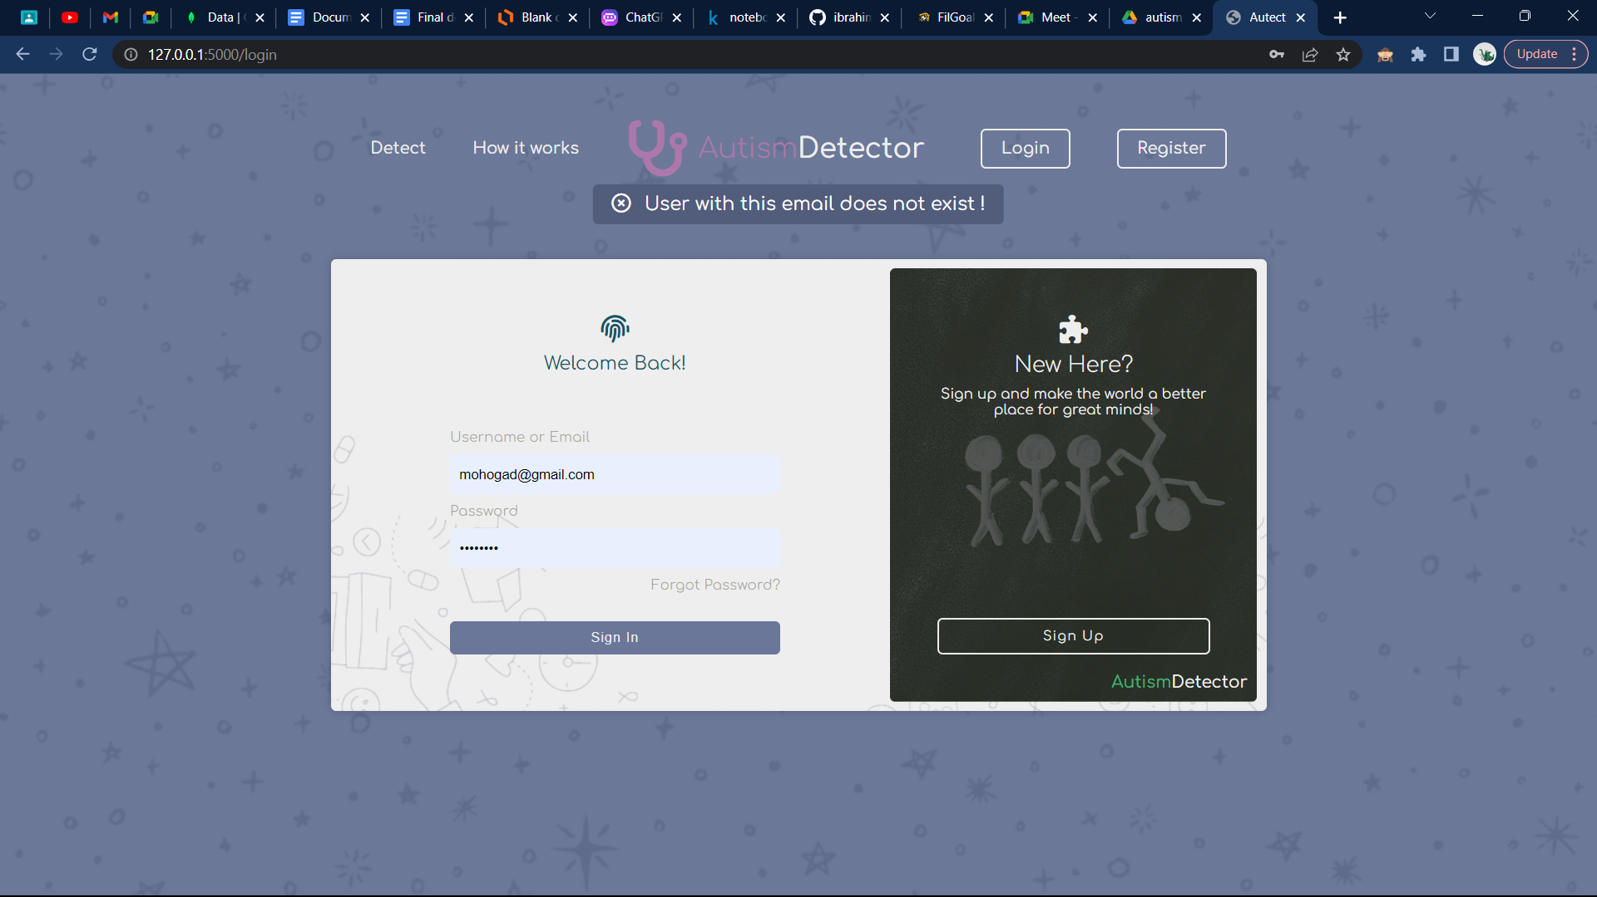

Figure 5.4.5: Email login error

**5.4.6. Welcome message after logging in successfully**

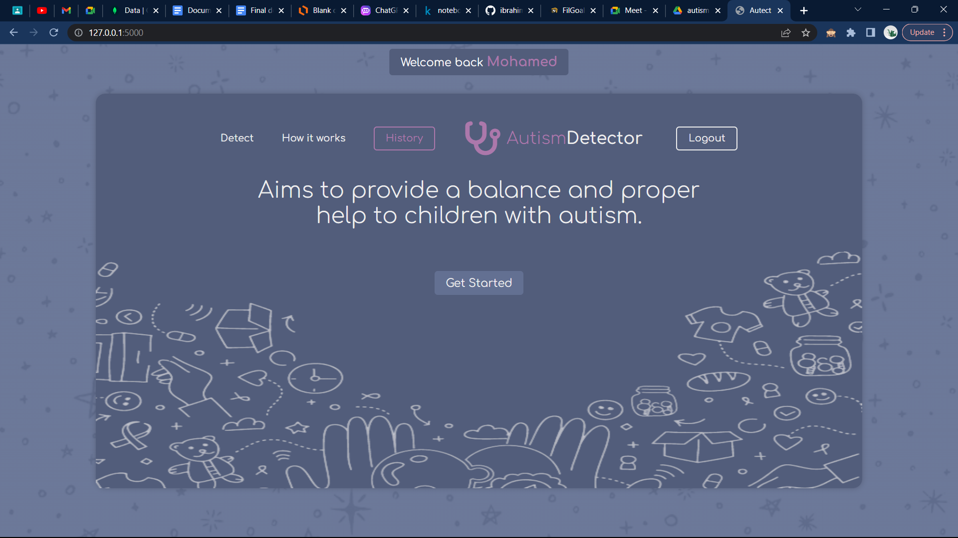

Figure 5.4.6: Welcome msg

**5.4.7. Upload Image**

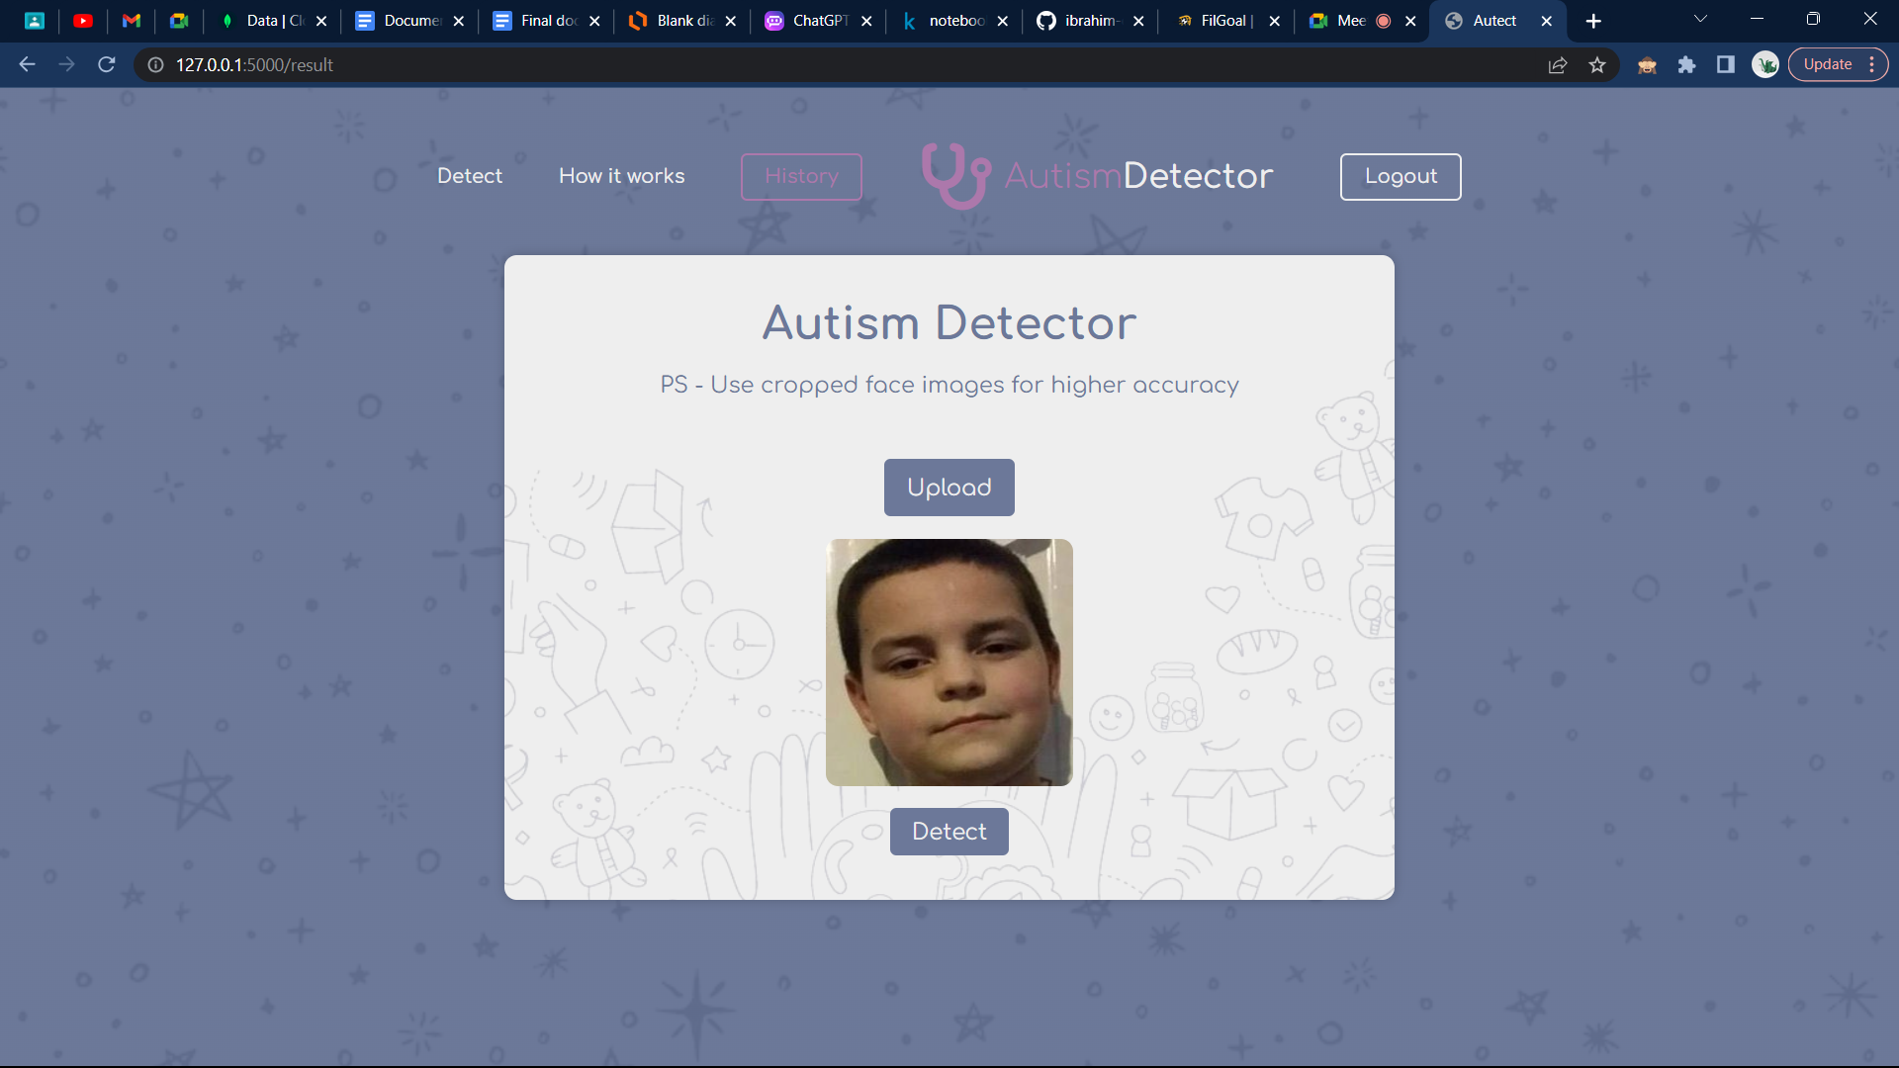

Figure 5.4.7: Upload img

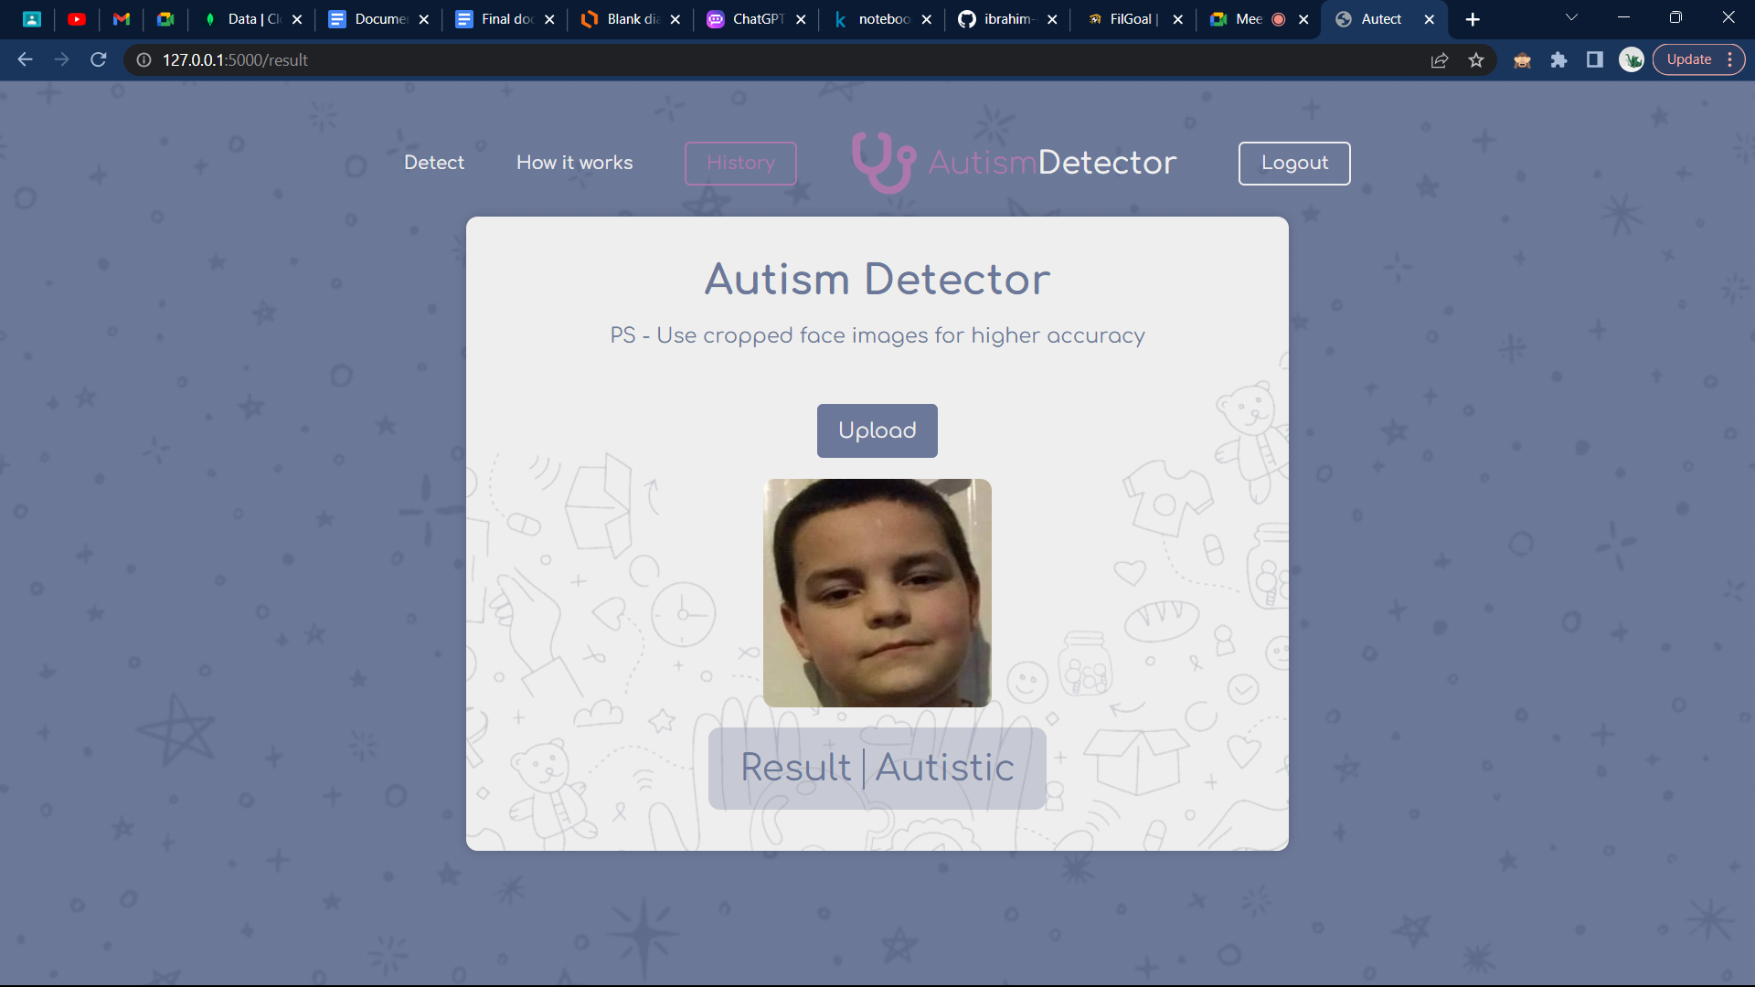**5.4.8. Detect Autism**

Figure 5.4.8: Detection Result

**5.4.9. View recent history**

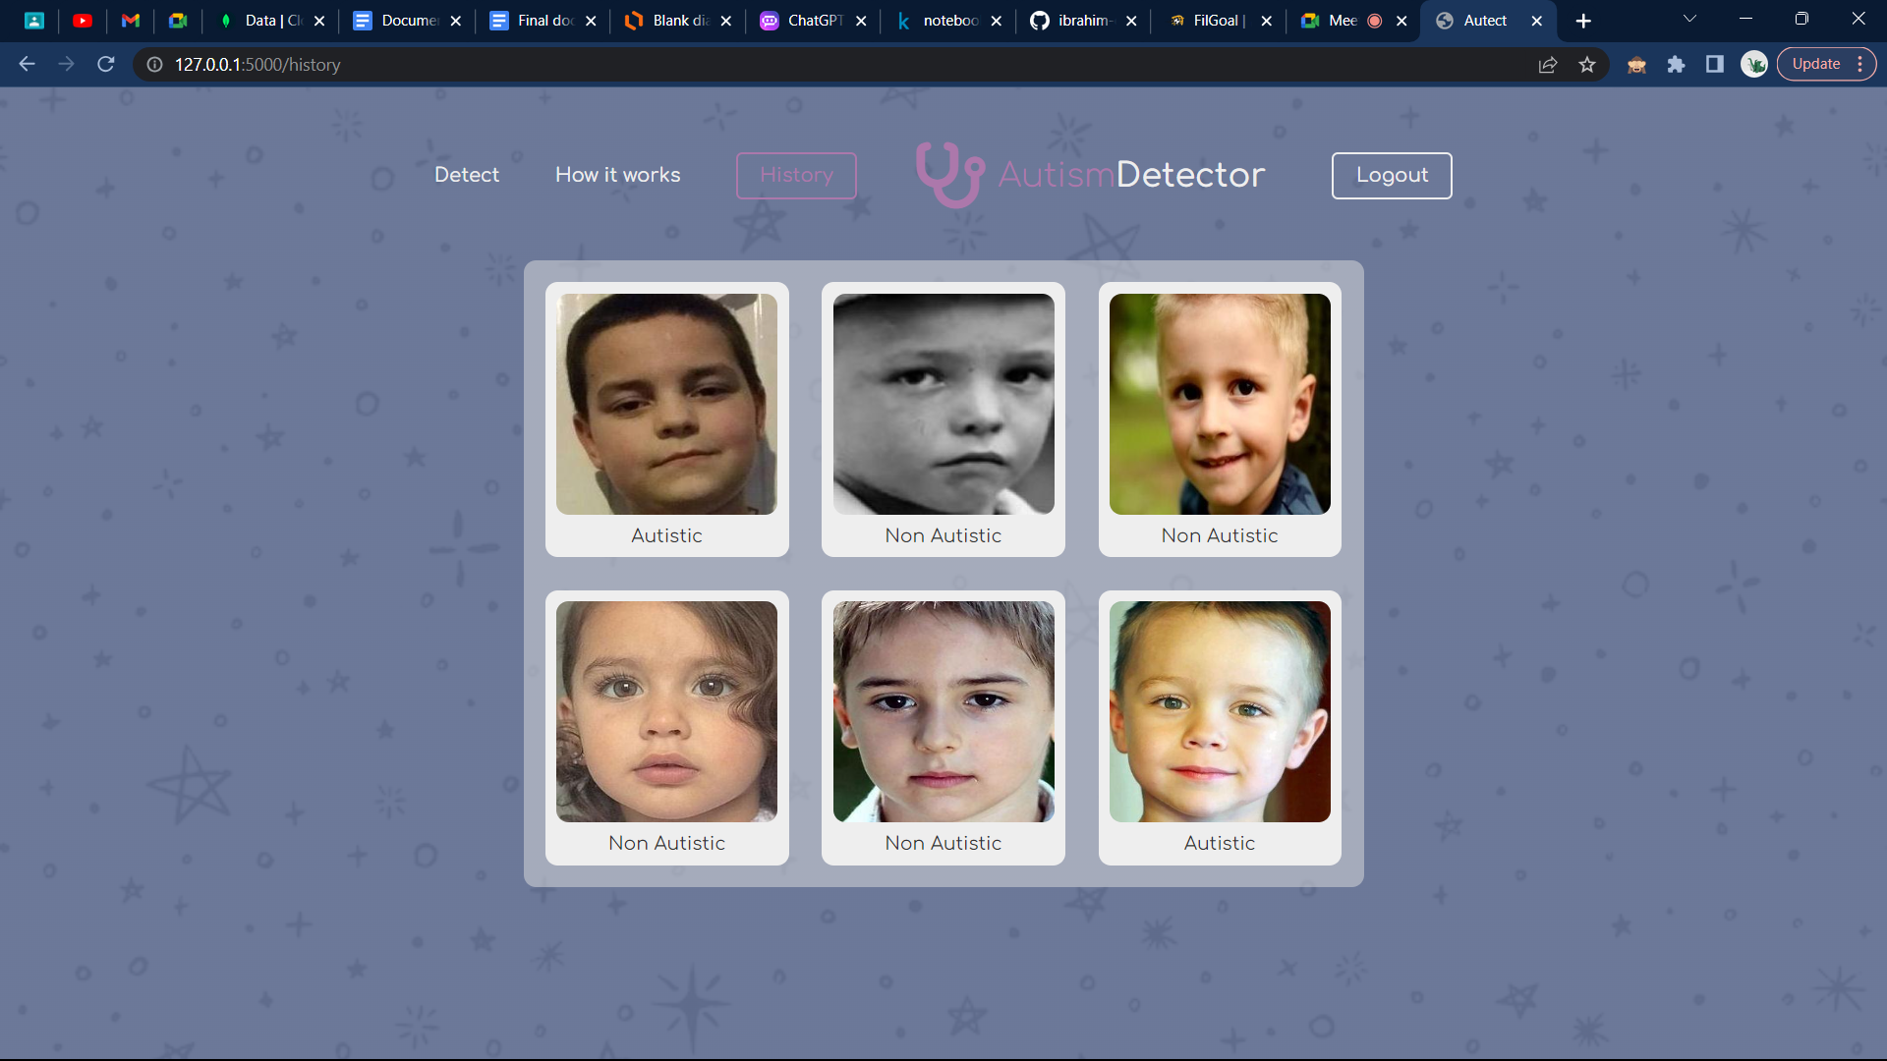

Figure 5.4.9: History

**5.4.10. User logged out**

Figure 5.4.10: Logout

**Chapter 6: Results**

**6.1. First Approach**

|  |  |  |
| --- | --- | --- |
|  | **Model Name** | **Accuracy** |
| 1 | KNN | 94% |
| 2 | SVM | 76% |
| 3 | Random Forest | 95% |
| 4 | Logistic Regression | 76% |
| 5 | Naive Bayes | 96% |
| 6 | NN | 98% |

Table 6.1: First Approach Model Accuracy

**6.2. Second Approach**

|  |  |  |
| --- | --- | --- |
|  | **Model Name** | **Accuracy** |
| 1 | DenseNet201 | 90% |
| 2 | ResNet152V2 | 83% |
| 3 | VGG16 | 81% |
| 4 | InceptionV3 | 83% |

Table 6.2: Second Approach Model Accuracy

**References**

**[1]** A Computer Vision Based Approach for Understanding Emotional Involvements in Children with Autism Spectrum Disorders

<https://www.researchgate.net/publication/322647691_A_Computer_Vision_Based_Approach_for_Understanding_Emotional_Involvements_in_Children_with_Autism_Spectrum_Disorders>

**[2]** Facial Features Detection System to Identify Children with Autism Spectrum Disorder: Deep Learning Models

<https://www.ncbi.nlm.nih.gov/pmc/articles/PMC9001065/>

**[3]** Identification of Autism in Children Using Static Facial Features and Deep Neural Networks

<https://www.mdpi.com/2076-3425/12/1/94>

**[4]** Dataset

<https://www.kaggle.com/datasets/cihan063/autism-image-data>